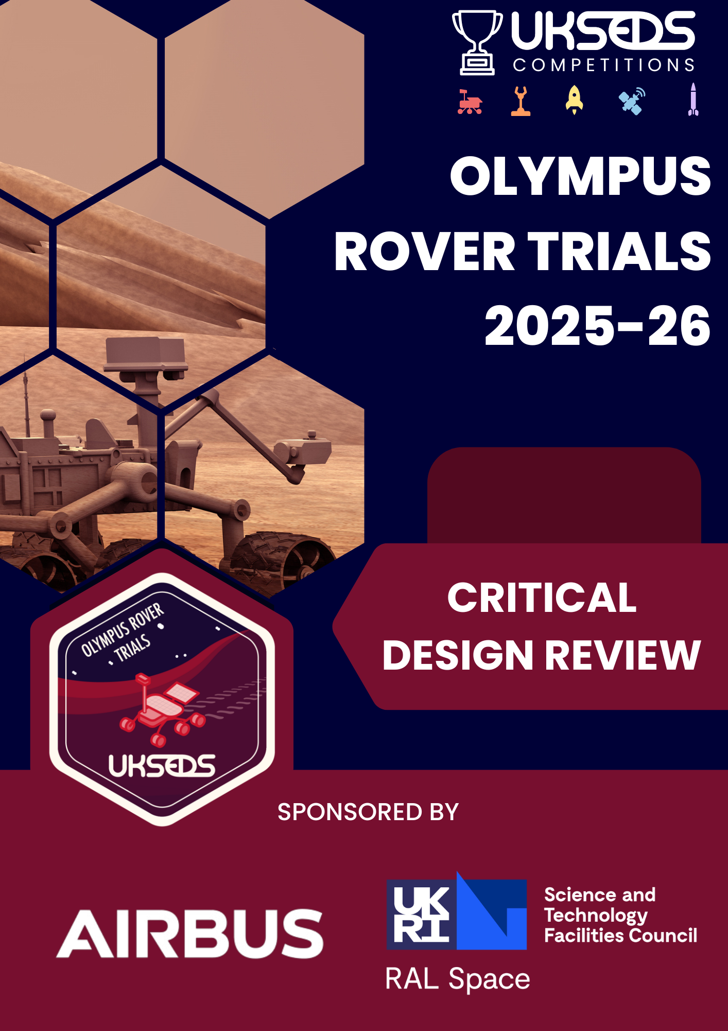

Error 404: Gravity Not Found

OLYMPUS ROVER TRIALS

2025 – 2026

Error 404: Gravity Not Found



Issued by (Project Lead): Kyra-Tamsin Manuel
University: Queen Mary University of London

1. Introduction 4
1.1 Mission Statement 4
2. Project Management 5
2.1. Assigned Roles & Team Roster 5
2.2. Complete Schedule 6
2.3. Complete Budget 6
2.4 Project Risks & Mitigations 7
2.5 Stakeholder Analysis 10
3. Rover Design 10
3.1. System Overview 10
3.1.1 Mass and Volume Requirements 12
3.1.2 Manufacturing Plan 13
3.1.3 Cleaning Procedure 14
3.2 Mechanical Design 14
3.2.1 Camera Mount 14
3.2.2 Chassis 18
3.2.3 Vibration Table Interface 22
3.2.4 Motor Housing and Suspension 23
3.2.5 Wheels 25
3.2.6 Material Selection 27
3.3 Electrical Design 28
3.3.1 Camera Selection 30
3.3.2 Battery Selection 31
3.3.3 Battery Safety 32
3.3.4 Motor Selection 34
3.3.5 Distance Sensing 34
3.3.6 Communications 35
3.4 Software Design 37
3.4.1 Overview 37
3.4.2 Development approach 38
3.4.3 Architectural Philosophy 38
3.4.4 Software Stack 38
3.4.5 Development workflow 39
3.4.6 Advantages of this Approach 40
3.4.7 Link to GitHub Repository 40
4. Test Procedure 41
5. Concept of Operation 45
6. Compliance matrix 45
7. Acknowledgements 51
8. References 51
9. Appendices 52
Appendix A: Complete Schedule 52
Appendix B: Bill of Materials 58
Appendix C: Requirements 60
Appendix D: Verification of Servo Torque for Camera Mount 64
Appendix E: Engineering Drawings 69

Introduction
Error 404: Gravity Not Found is the Olympus Rover Trials team from QMSEDS, Queen Mary University of London’s branch of UKSEDS. Our team consists of 10 aerospace and mechanical engineering students, along with master's students in AI and robotics. We are competing in this challenge because we are eager to learn new skills, develop our technical abilities, and contribute to a project we are genuinely passionate about. In addition, many team members have not previously contributed to a large project in the space sector, so this is a valuable opportunity for us to develop a concept and produce a technical report that aligns with industry standards.

1.1 Mission Statement
As human exploration of the Moon and nearby planets resumes with missions such as NASA’s Artemis program (NASA), the possibility of inhabiting Mars is drawing nearer. However, before humans can travel to Mars, a detailed understanding of the Martian environment will be essential for identifying key challenges and developing the technologies needed to support long-term human presence on the planet. In this context, we have been tasked with developing a rover capable of operating within a geological crater, capturing images of key features, and transmitting them back to Earth.
To achieve this, we will design a rover capable of navigating to specific target locations while avoiding obstacles in the RAL Space Mars Yard. With many team members highly skilled in programming, a primary goal is to make certain functions of our rover autonomous, ultimately progressing toward full autonomy. This focus will strongly influence our design decisions and will require integrating additional sensors and sufficient processing capability.
Throughout the project, we will draw inspiration from established industry rover designs while applying innovative and creative concepts to meet our requirements efficiently. This approach will ensure our rover stands out both technically and creatively.

Project Management

Assigned Roles & Team Roster
Table 1: List of team members and assigned roles
Name | Role | Year/Course | Email
Kyra-Tamsin Manuel | Team Lead and Mechanical Engineer | 2nd Year, MEng Aerospace Engineering | k.manuel@se24.qmul.ac.uk
Staines Rajith | Vice Team Lead and Electrical Engineer | MSc Robotics and AI | s.rajithgnanasigamani@se25.qmul.ac.uk
Julius Kucinskas | Mechanical Lead | 2nd Year, MEng Aerospace Engineering | j.kucinskas@se24.qmul.ac.uk
Asmitha Anbazhagan | Mechanical Engineer and Outreach Lead | 1st Year, BEng Mechanical Engineering | a.anbazhagan@se25.qmul.ac.uk
Syed Younus Ali Tanvir | Mechanical Engineer | 3rd Year, BEng Mechanical Engineering | s.tanvir@se22.qmul.ac.uk
Onur Kurt | Electrical Lead | MSc Robotics and AI | o.kurt@se25.qmul.ac.uk
Ahmed ElSayed | Electrical Engineer | MSc Robotics and AI | Ex25049@qmul.ac.uk
Osinachi Odemena | Software Lead | MSc Robotics and AI | ex25089@qmul.ac.uk
Momoh Oluwaniyi | Software Engineer | MSc Robotics and AI | ex25481@qmul.ac.uk
Hamad Aljamaan | Software Engineer | MSc Robotics & AI | Ex24056@qmul.ac.uk

Our team will have a lead and a vice lead who will be responsible for organising and facilitating meetings, ensuring deadlines are met, and completing monthly progress updates. The team will be divided into three sub-teams: mechanical, electrical and software. Each will have a team lead who will manage their respective subsystems. Additionally, one team member has also been assigned as outreach lead and will be responsible for organising and recording any outreach activities our team takes part in.

Complete Schedule

The complete schedule, with a full breakdown of the main tasks each sub-team needs to carry out throughout the project, can be found in Appendix A.
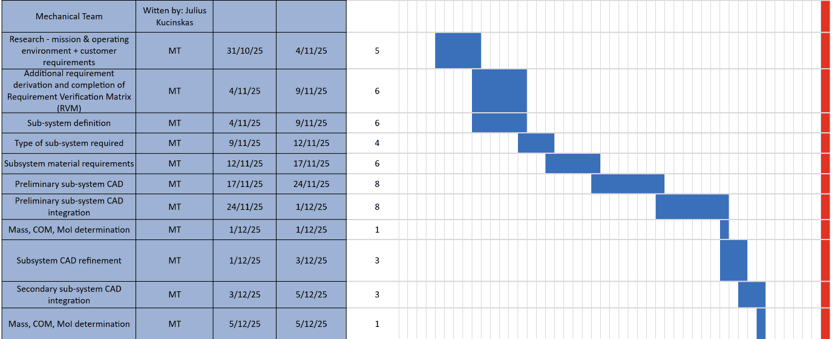

Figure 1: Snapshot of the general mechanical team tasks as part of the complete schedule.

Complete Budget
Our total budget is £400, consisting of £208.33 from team membership contributions and £191.67 allocated to QMSEDS from Queen Mary University of London. Based on the final budget shown in Table 2, we estimate the rover will cost £335 to build. An additional contingency of 10–20% has been allocated to each subsystem to account for potential price fluctuations and ensure sufficient funds remain available to complete the rover. This brings the estimated total cost to £375 leaving approximately £25 remaining within our overall budget. The complete bill of materials can be found in Appendix B.

Table 2: Final Budget
Subsystem | Component | Cost (£) | Contingency
Mechanical | 3D Printer Filament | 27.18
 | Servos | 0
Total |  | 27.18 | 20% (£5)
Electrical | Processor | 69.45
 | Communication | 42.33
 | Camera | 24
 | Battery System | 42.33
 | Motor System Components (motors, motor drivers, etc.) | 133
 | Sensors | 6.49
 | Safety (kill switch, etc.) | 1.50
Total |  | 284.31 | 10% (£30)
Misc. | Screws and Fixings | 20.62
 | Cables | 2.40
 | Cleaning Equipment | 0
 | Manufacturing | 0
Total |  | 23.02 | 20% (£5)
 | Total | 335 | 375

2.4 Project Risks & Mitigations
The main risks associated with this project have been identified and categorised into safety and programmatic risks. The risk level and mitigation methods have also been identified and a revised score based on these mitigation methods was given.
Table 3: Safety Risks and Mitigations
Risk ID | Category | Description | Effects | Severity | Likelihood | Risk (1-25) | Mitigation Action | Revised Score (1 – 25)
1 | Manual Handling | Lifting heavy parts or working in awkward positions during rover assembly | Strains, fatigue, or injury | 3 | 2 | 6 | Use lifting aids; PPE for support; training in handling; take frequent breaks | 2
2 | Machinery/Tools | Injuries from power tools or moving rover parts (during testing or build) | Cuts, pinches, or serious injury | 3 | 2 | 6 | Train for machine/tool use; PPE (gloves/goggles); never leave machines unattended | 3
3 | Electrical Hazards | Risks of electric shock or wiring faults during electronics testing | Serious injury, failed circuits, fire risk | 4 | 2 | 8 | Inspect wiring; use insulated connectors; regular maintenance; PPE | 4
4 | Slips/Trips/Falls | Workshop or lab hazards, e.g., cluttered workstations or trailing cables | Body injury, lost work time | 2 | 2 | 4 | Keep workspaces tidy; secure cables/tools; suitable footwear | 2
5 | Battery Safety | Battery may swell or overheat | May damage the electronic parts or cause injury. | 5 | 2 | 10 | Use the correct charger/voltage, inspect regularly. | 5
6 | Soldering | Burns or inhale toxic fumes. | Skin burns, causes irritation when inhaled. | 3 | 3 | 9 | Use heat proof mat. | 3
7 | 3D Printing | High heat and Fire hazard | Contact burns | 3 | 3 | 9 | Thermal protection | 3

Table 4: Programmatic Risks and Mitigations
Risk ID | Category | Description | Effects/Consequences | Severity | Likelihood | Risk Score (1-25) | Mitigation Action | Revised Score (1-25)
8 | Budget | Unexpected costs (e.g., failed components, extra materials, shipping delays) | Project over budget, need for cost-cutting | 5 | 2 | 10 | Track all purchasing; set a contingency budget; compare supplier reliability | 5
9 | Schedule | Missed deadlines or launch milestones due to resource issues or team member absence | Delayed rover deployment, risk of missing launch window | 5 | 3 | 15 | Plan deadlines early; maintain a project tracker; monitor weekly progress | 5
10 | Team | Unexpected team member drop-out or lack of key expertise | Knowledge gaps, reduced productivity | 3 | 1 | 3 | Spread critical knowledge; maintain updated documentation; cross-training | 1
11 | Technical Quality | Rover/platform fails to meet mission specs (mobility, sensor accuracy, autonomy) | Mission objectives not met, failed competition/research | 5 | 3 | 15 | Test subsystems early and often; validate against requirements; stage reviews | 5
12 | Parts/Procurement | Delays in delivery of essential rover components (motors, boards, sensors) | Project halted, forced redesign/substitution | 3 | 3 | 9 | Order parts early; track shipments closely; favor reputable suppliers | 3
13 | Communication | Poor integration and information flow between hardware/software teams | Faulty system integration, bugs, wasted effort | 4 | 3 | 12 | Run regular cross-discipline meetings; use online communication tools | 4
14 | Time Management | Rushed completion and poor prioritisation of work leads to mistakes or incomplete systems | Increased rework, overlooked components | 4 | 5 | 20 | Prioritise critical tasks; delegate effectively; monitor working hours | 8
15 | Competition/Field | Failure during final testing/competition day; missing spares | Unable to complete mission/test | 5 | 2 | 10 | Prepare spare parts and tools; check all equipment beforehand | 2
16 | Integration Failure | When the hardware and software components fail when put together. | Rover may not work or move. | 3 | 3 | 9 | Test each part before connecting them together. | 3
17 | Data loss | Error in CAD or losing files. | Delays from needing to remake the CAD | 3 | 3 | 9 | Make regular back ups. | 3
18 | 3D Printing | Printing failure | Material waste, time delay | 3 | 4 | 12 | Print prototype, start printing early. | 3

2.5 Stakeholder Analysis
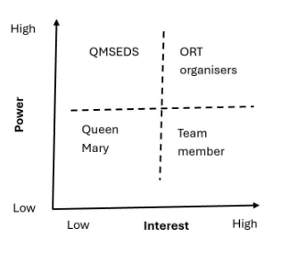
Figure 2: Stakeholder Diagram

The main stakeholders were identified and analysed to ensure that project developments, risks, and challenges are communicated effectively and in a timely manner, supporting informed decision-making and alignment with the project objectives.

Rover Design

System Overview
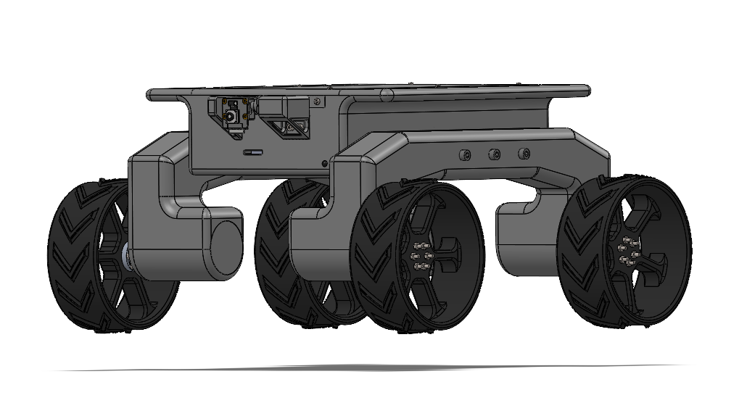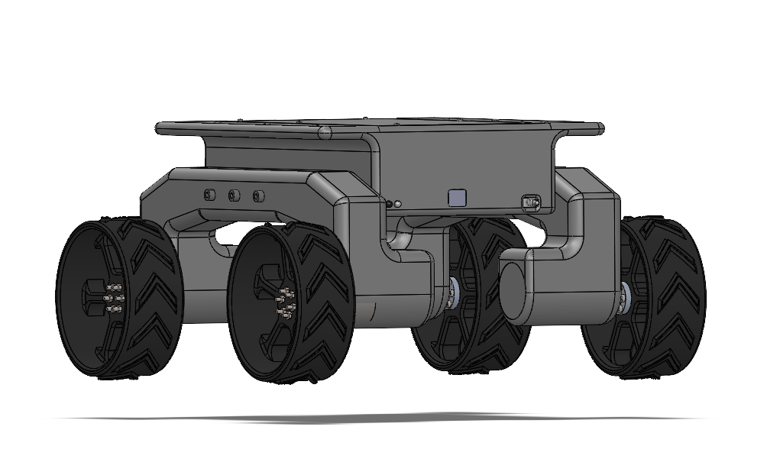
Figure 3: Complete CAD Model of Rover

The rover will have a four-wheel drive configuration, with each wheel powered by an independent DC motor to provide enough traction and torque for driving over uneven terrain. A hollow motor mount will connect the motors to the chassis, while providing support and protecting the motors’ cables from damage. A camera will be mounted on a single-servo mount that enables rotation in the pitch direction, allowing the viewing angle to be adjusted during operation. The chassis will have a removable top lid to allow access to the internal electrical components for maintenance and manufacturing. For safety, a manual kill switch that cuts power to all components will be positioned at the back of the rover. There are also openings for the IR sensors on the front and back of the chassis and a dedicated access port for the Raspberry Pi’s Ethernet connection, as this has been selected as the backup communication method.
The rover’s electrical system has been developed to ensure robust performance and safety. Power will be supplied by a 3S LiPo battery system with upgraded wiring and a dual-power distribution configuration to support the high-current demands of the drive motors. A 40-amp Battery Management System (BMS) provides overcurrent protection and battery safety, while a manual toggle switch allows the entire system to be safely powered on or off. Motor control is handled by MDD10A dual-channel motor drivers, which regulate the operation of the high-torque DC motors for rover locomotion. Environmental awareness is provided through two digital infrared sensors. Lastly, the communication system is designed in a bifurcated format: Wi-Fi is used to transmit high-bandwidth video, and a 2.4-GHz LoRa link provides low-latency motor control, thereby enabling continuous operation without the duty-cycle restrictions of sub-GHz bandwidth.
The rover's software architecture is designed to provide a high-integrity link between the physical hardware and the operator interface, ensuring reliable mission execution. By utilising a modular framework on the Raspberry Pi, the system manages real-time locomotion and telemetry reporting while maintaining a strict heartbeat timeout that automatically triggers a safe state during any signal interruption. Navigation and mission tasks are coordinated through a base station laptop, where a low-latency video stream and an Xbox controller provide the pilot with responsive teleoperation capabilities.
This control environment is enhanced by an intelligent vision pipeline that performs real-time QR detection and automatically captures high-quality frames once specific quality thresholds are met. To guarantee data traceability throughout the thirty-minute mission, a dedicated management module organises every captured image and decoded output into a structured format with precise timestamps. Communication resilience is further reinforced by a dual-layered approach that prioritises wireless stability while offering a wired Ethernet fallback for contingency operations.

3.1.1 Mass and Volume Requirements
Table 5: Mass of Components
Subsystem |  | Component | Quantity | Est. Unit Mass (kg) | Est. Total Mass (kg)
Electrical |  | Motor Mounting Hub | 4 | 0.0068 | 0.0272
 |  | Camera | 1 | 0.005 | 0.005
 |  | Sensors | 1 | 0.015 | 0.015
 |  | Processor | 1 | 0.05 | 0.05
 |  | Communication | 1 | 0.005 | 0.005
 |  | Batteries | 2 | 0.380 | 0.760
 |  | Motors | 4 | 0.150 | 0.600
 |  | Motor Driver | 2 | 0.030 | 0.060
 |  | Kill Switch | 1 | 0.010 | 0.010
 |  | BMS | 1 | 0.010 | 0.010
Mechanical |  | Chassis | 1 | 0.398 | 0.398
 |  | Chass Lid | 1 | 0.0734 | 0.0734
 |  | Motor Mount | 2 | 0.362 | 0.724
 |  | Servo Camera Mount | 1 | 0.036 | 0.036
 | Wheels |  | 4 | 0.104 | 0.416
 |  |  |  | Total | 3.17

The approximate total mass of the rover has been calculated as 3.17 kg (not including any screws or fixings, which are expected to weigh below 100g in total), which is below the maximum mass allowance of 5 kg (see Appendix C, requirement 1).
The boxed volume is 0.0288 m³, which is also below the limit of 0.03 m³ (requirement 2).

3.1.2 Manufacturing Plan
The first phase of manufacturing is the procurement of all electrical components. After successfully passing the Critical Design Review (CDR), we will place orders, as delivery times must be considered.
The next phase is 3D printing. Since multiple team members have access to printers, this work will be divided among the team to reduce production time. PLA will be used for the chassis components, while PETG will be used for the wheels and motor housings due to its greater impact resistance, as discussed later.
Once all components have arrived, we will verify each electrical component individually to ensure proper functionality. Following this, we will proceed with electrical assembly, which includes soldering connections and integrating all components. After completing the electrical assembly, we will conduct initial system tests. Final assembly will then take place, involving mounting the electrical components onto the chassis and attaching the motor housings and wheels.
The final phase will be full system testing according to our test plan to confirm that all systems perform as expected (see 4 Test Procedure). Any issues identified during this stage will be addressed and resolved.

3.1.3 Cleaning Procedure
To ensure the rover is suitable for placement on the vibration table, it will be thoroughly cleaned after the test run.
Before cleaning, the rover will be fully powered off and the batteries disconnected. Loose dust and debris will be removed using a soft brush. The external surfaces will then be wiped using a damp microfibre cloth. Special care will be taken around sensitive areas, such as around the IR sensors, camera and Ethernet access port.
To prevent dust and dirt from entering the rover, all access points will be covered. The Ethernet access port will be covered with a 3D printed snap-fit cover, designed to be removable while preventing dust from entering the chassis. The main access lid has a wide lip to prevent dust from entering. The IR sensors will be fixed using superglue and inspected to ensure that there are no gaps through which dust could enter.

3.2 Mechanical Design

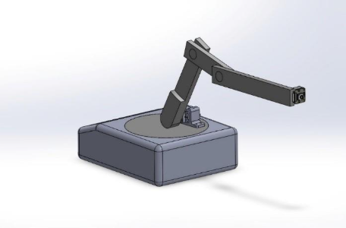
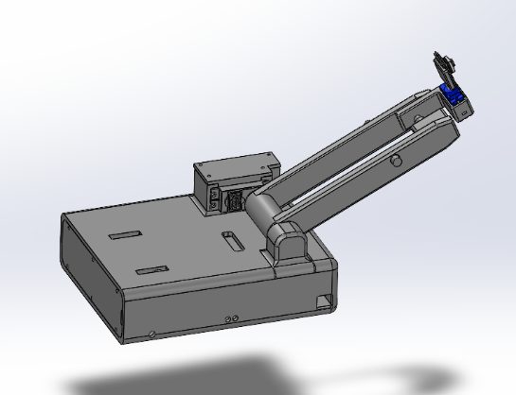
3.2.1 Camera Mount
1
2
3
Rotating platform
1
2
3

(b)
(a)

Figure 4: Initial PDR camera arm with arms labelled (a) and labelled second iteration of camera arm (b).

An articulated arm (Figure 4 (a)) was initially selected as the system to orient the camera and ensure clear visibility of the QR codes. The original design featured four degrees of freedom and four servo motors. However, following feedback received during the PDR and further evaluation of the concept, it became clear that this approach was overly complex. It would be challenging to implement from a software perspective and would also increase power consumption.
The design was subsequently simplified to three degrees of freedom. While this reduced complexity and improved feasibility, it added mass and still incorporated a relatively high number of moving parts, thereby increasing the number of potential failure points. Therefore, the articulated arm was removed and replaced with a single-servo camera mount.

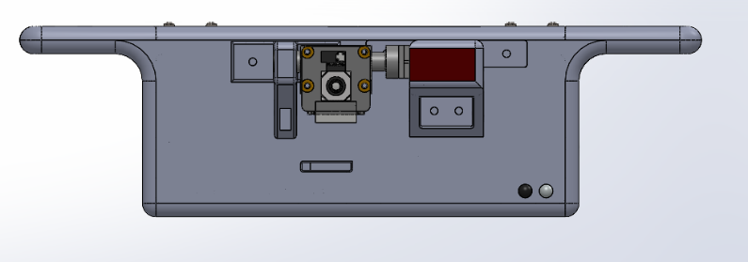
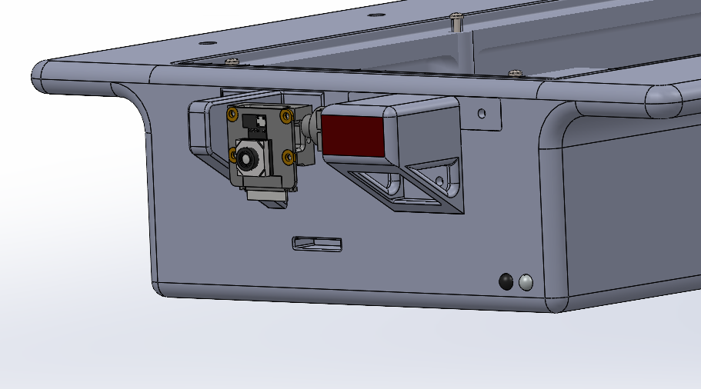

(b)
(a)

Figure 5: Single servo camera mount mechanism, oblique view (a) and front view (b).

This significantly reduces mechanical complexity and minimises the number of moving parts. With only one servo motor required, the control software is considerably simpler to implement, and overall power consumption is reduced.
The camera can still be rotated in pitch, which is sufficient to detect and view QR codes positioned up to 20 cm above or below the rover. Horizontal alignment is achieved by steering the rover itself, eliminating the need for additional rotational degrees of freedom in the camera mount. The structural support for the camera consists of three components: the camera mount, the MG92B servo mount and the roll support bracket for the camera mount.
MG92B servo interface (screw hole)
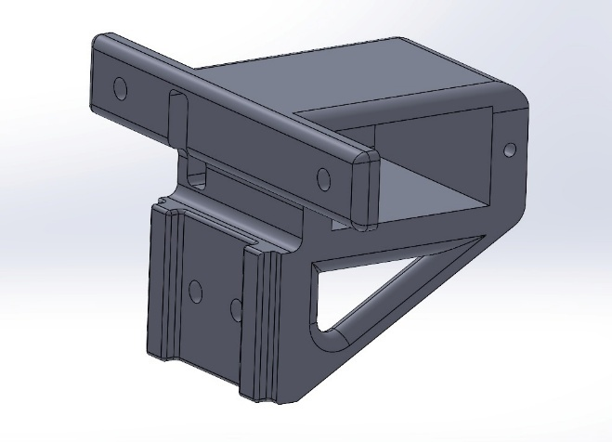
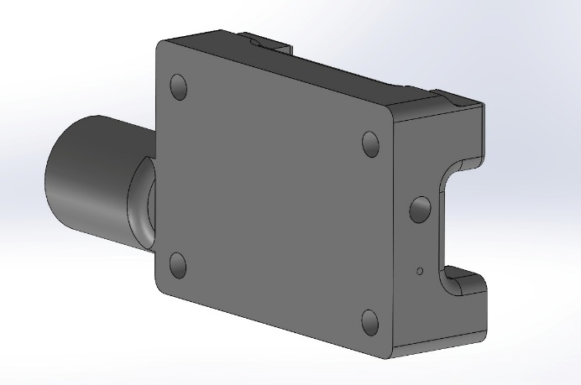
(b)
(a)

Servo wire bypass
(a)

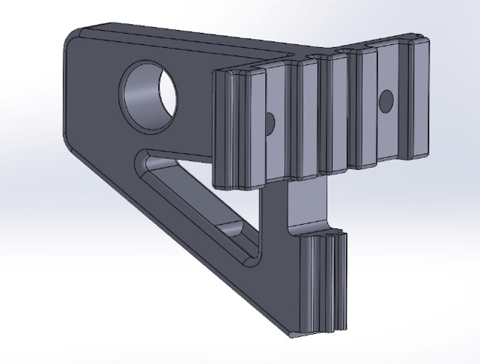
(c)

Figure 6: Structural Camera Mount Components

The camera mount has a circular extrusion of 8mm in diameter, such that it can be supported laterally by an additional support shown in Figure 6 (c), which has a circular diameter cut of 8.3mm to account for the tolerance as a result of the 3D print (refer to Appendix B for engineering drawings). This ensures that the stress acting on the servo is reduced, especially during launch vibrations, and that the mechanism remains functional after this phase of the mission.

Table 6: Screw Dimensions for Camera Supports
Self-tapping screws | Camera mount | Servo mount | Roll support bra.
M2 x 8mm | 5 | 2 | 0
M3 x 8mm | 0 | 3 | 2

In parallel with using self-tapping screws, both the camera mount and roll support bracket cavity inserts will be superglued to the chassis cavities, the geometry of which is chosen to maximise the surface area for glue application and hence a stronger overall bond between the structural components and the chassis.
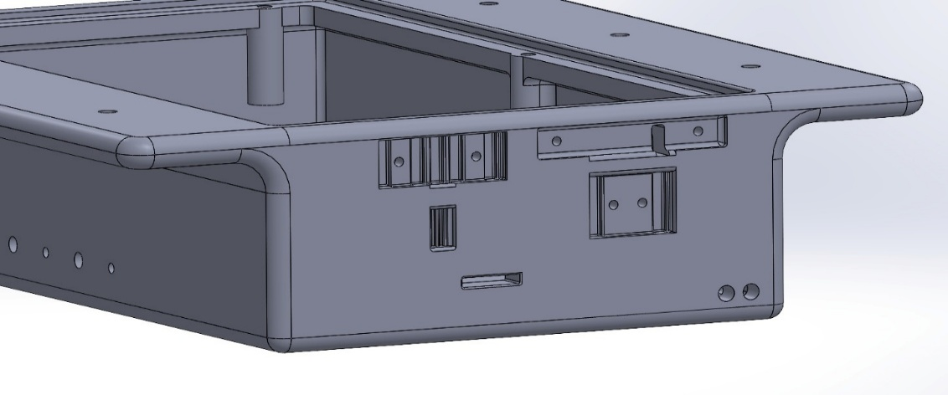

Figure 7: Chassis cavities as interfaces for the camera pitch mechanism.

Prototypes to test the screw holes for the self-tapping screws and the tolerance between the sides of the servo mount and the MG92B were 3D-printed in polylactic acid (PLA) to verify the applied tolerances.
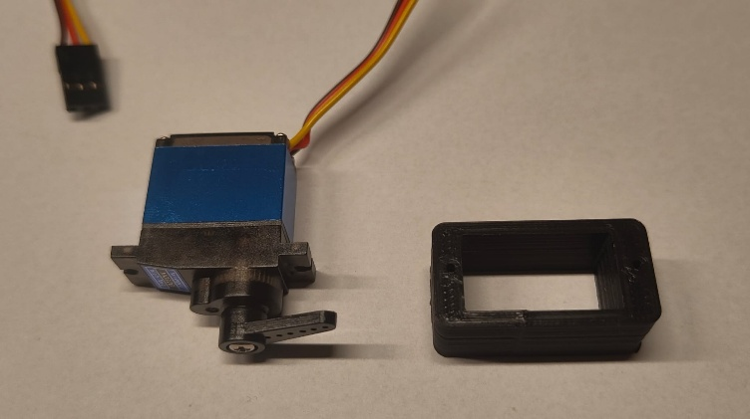
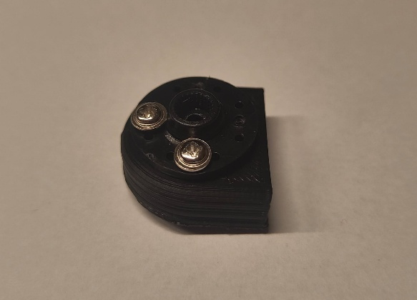

(b)
(a)
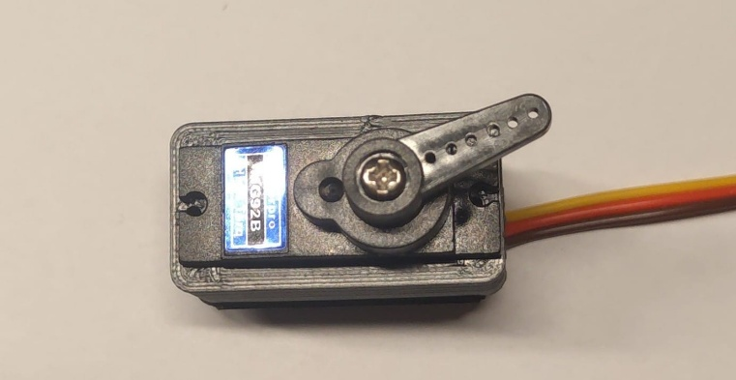

(c)

Figure 8: 2 M2 x 14mm self-tapping screws holding a servo horn and a component of the previous arm iteration (a), MG92B servo and 3D printed test case (b) and insertion of the servo into its case (screw hole misalignment present) (c).

From Figure 8, it was determined that 1.85mm holes were sufficient for a firm grip between the M2 screws and the PLA material and that the holes made to screw the MG92B servo needed to be translated 0.3mm vertically, such that the holes are closer towards being concentric with the cuts of the MG92B servo. This has been amended in the final CAD model.

3.2.2 Chassis
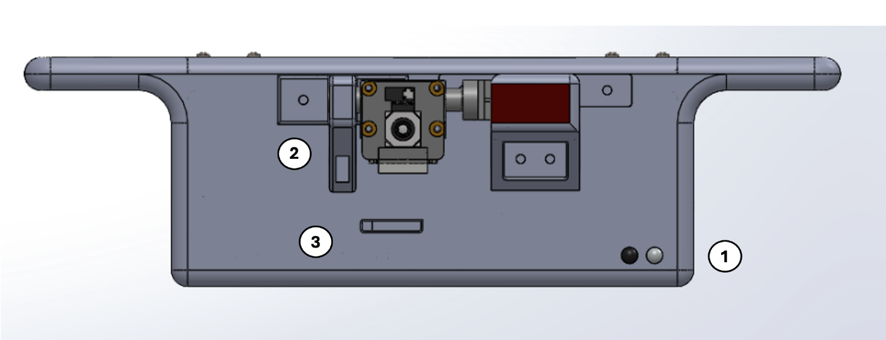
a)
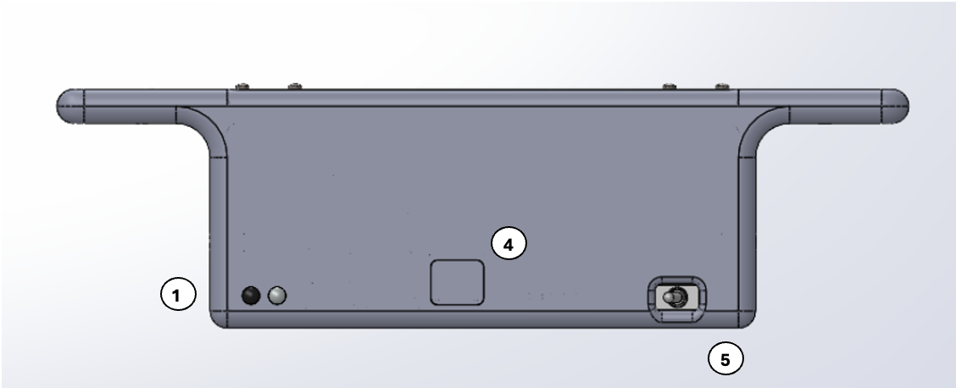
b)
Figure 9: a) Front view of chassis, b) Back view of chassis

- IR sensor mounting holes
- Camera servo mount
- Camera cable hole
- Ethernet Access Port and snap-fit covering
- Kill switch

The chassis design has been further refined, with key consideration given to manufacturability and resistance to vibration. All the corners are filleted, and screw holes are a suitable distance from the edges to prevent cracking. The chassis will be made of PLA and 3D printed.
The chassis has built-in holes so that the IR sensors, receivers, and emitters sit outside the rover, allowing them to detect the surroundings. There will also be a hole for the kill switch, which will be easily accessible and placed near the back of the rover to meet requirement 20 (see Appendix C). As both components are inexpensive and will not need to be removed, they will be secured with superglue, which will withstand the vibration test (Gluegun.com).
As Ethernet is our backup communication method, there will be a hole near the front of the chassis to access the Raspberry Pi’s Ethernet port. There will be a snap-fit PLA cover to prevent sand and dust from entering the rover and potentially damaging internal components.

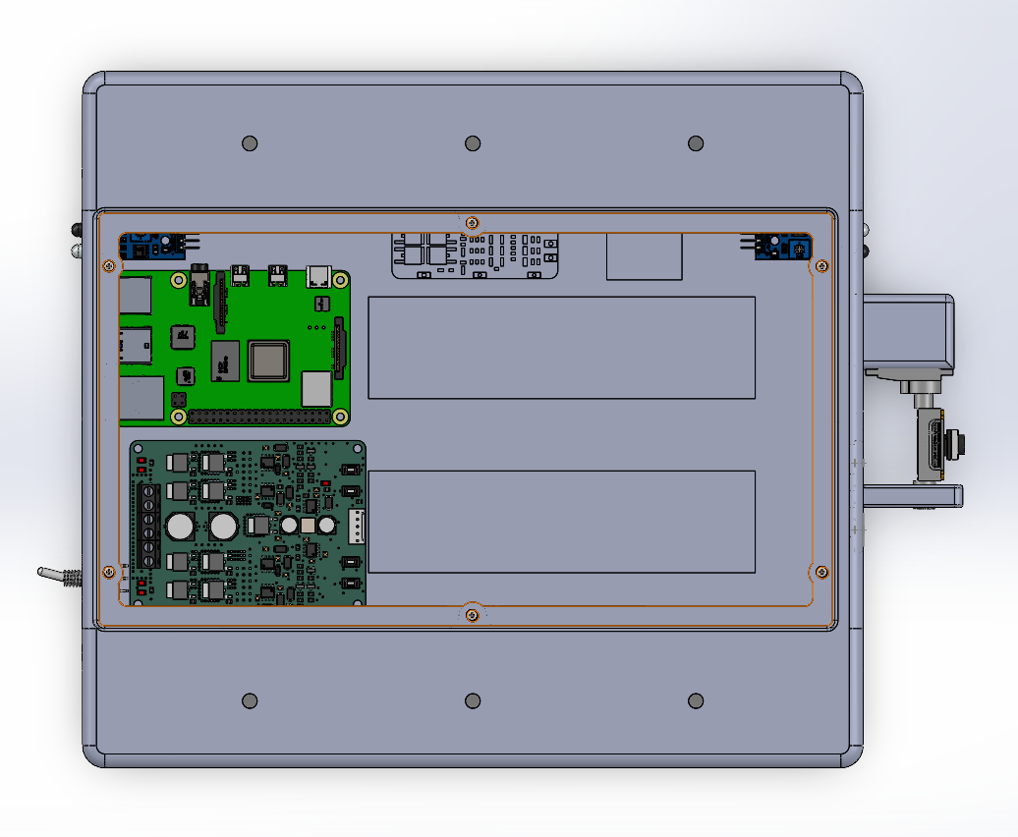
Figure 10: Internal components

The chassis has been sized to ensure all electrical components fit, with sufficient space to attach the required cables. Components with screw holes will be secured with suitable screws. The IR sensors and kill switch will be secured with Loctite superglue, as they are inexpensive and will not need to be removed. The batteries will be secured with Velcro tape for normal operation (so they can be easily removed for charging) and additional zip ties for the vibration table.

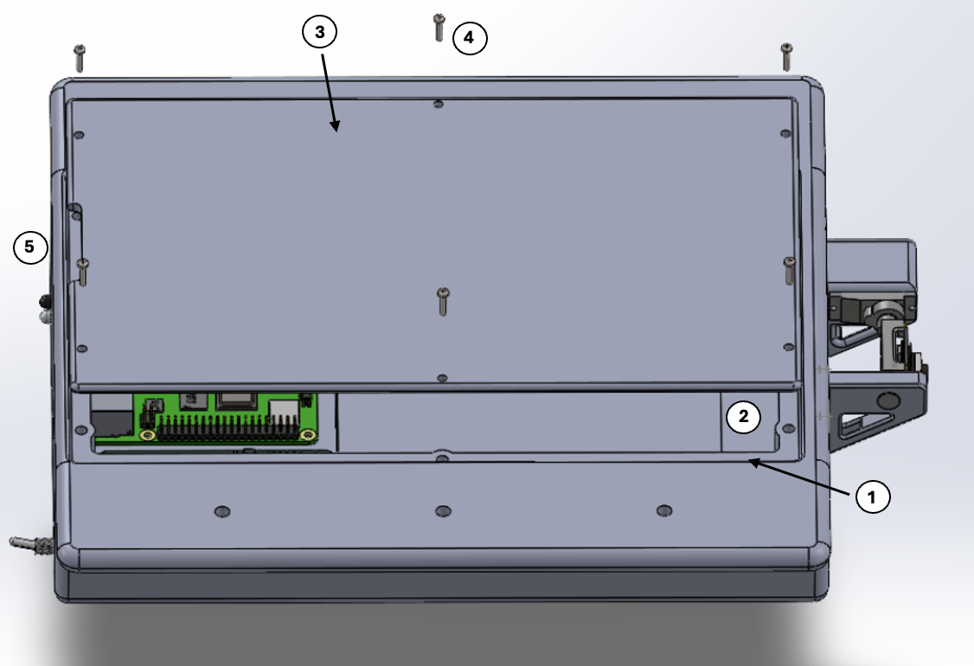
Figure 11: Chassis Lid Annotated CAD Model

- Recessed Lip
- 8 mm screw bosses
- Chassis lid
- M3 x 10 mm socket cap head screws
- Thumb access notch

There is a lid on the top to access the internal electronics. A top-opening lid was selected because it will make it easier to access and repair all electrical components in the rover. The lid will have a thumb-access notch to make it easy to remove and will sit on a recessed lip to improve resistance to vibrations and reduce stress on the screws, as well as providing a better seal against dust and debris. The best method for attaching the lid to the 3D-printed chassis was considered.

Table 7: Comparison of Lid Attachment Methods
Method | Advantages | Disadvantages
Printed Threads | - Cheap  - No extra hardware  - No additional assembly | - Low strength  - Wears quickly  - Additional design and printing complexity  - Requires fine print settings
Heat-Set Threaded Inserts | - Very strong  - Safe to disassemble often  - Good pull-out resistance | - Requires inserts  - Significantly more expensive  - Can be misaligned
Captive Nuts | - Very strong  - No additional tools required | - Takes up more space  - More design consideration  - Can be hard to insert
Screwing into the Plastic | - Cheap  - No extra parts  - No additional assembly | - Threads can wear out  - Can crack layers  - Lower strength

The method needed to be strong and vibration-resistant, while still being inexpensive. As we have access to a soldering iron, we decided to go with heat-set threaded inserts, as they are extremely strong and durable and will allow us to remove the lid to access the components without the threads wearing out. Six M3 screws will be used, providing a balance between securely fastening the lid and allowing easy access to the internal components. In addition, 8 mm diameter screw bosses with filleted edges will be used to prevent cracking while allowing the walls to remain thin.

3.2.3 Vibration Table Interface
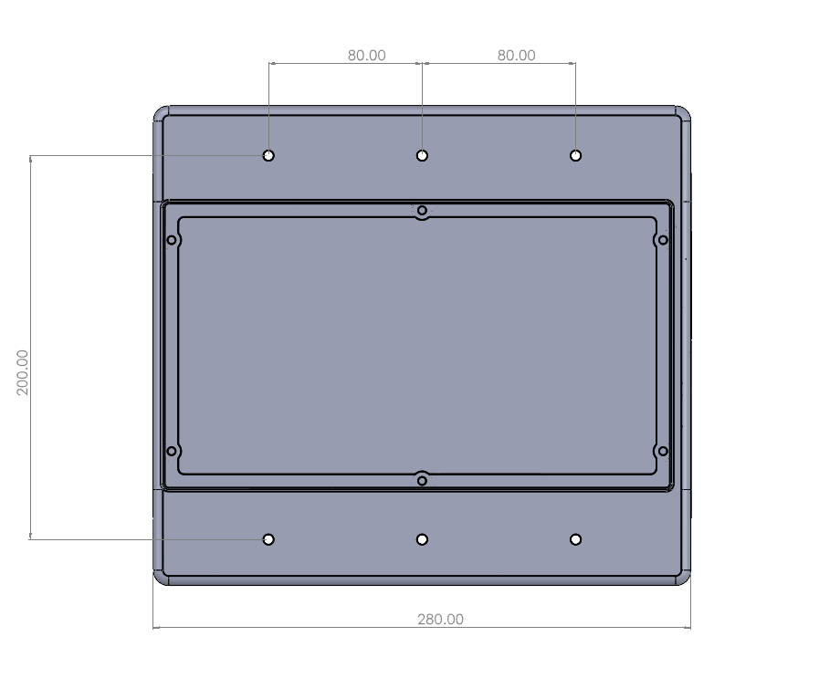
Figure 12: Top View of Chassis Showing Vibration Table Interface

After confirming that the vibration table mounting interface must remain attached to the rover at all times, the design was refined accordingly.
During testing, the rover will be mounted upside down on the vibration table, with the top surface facing downward. Two rectangular flanges extend from either side of the chassis, each containing three M5 mounting holes, providing a total of six attachment points. This configuration exceeds the minimum requirement of three attachment points and ensures secure, evenly distributed support to maintain stability during testing.
M5 × 20 mm screws will be used for mounting. This results in approximately 10 mm of thread engagement within the vibration table, remaining below the maximum allowable depth of 12.7 mm. Additionally, 15 mm washers will be used with the screws to distribute the load and reduce the risk of cracking in the printed components.

3.2.4 Motor Housing and Suspension
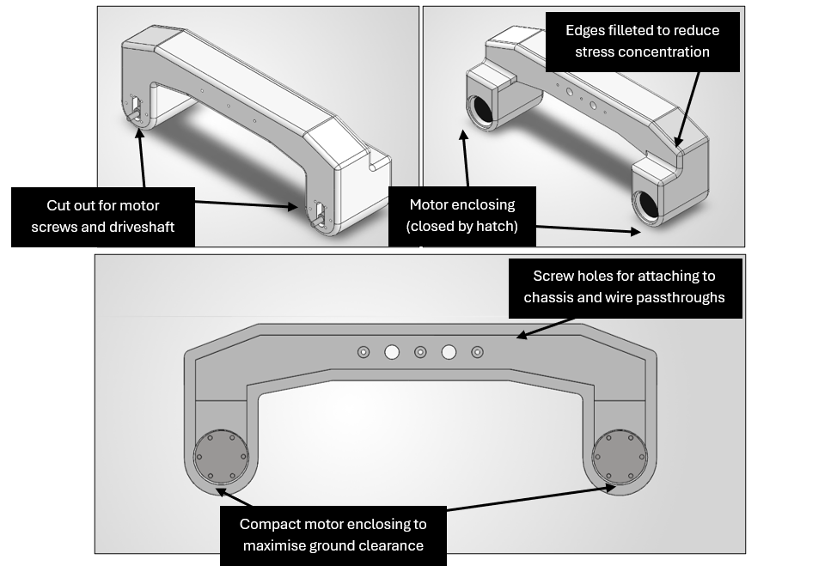Figure 13: Motor Mount Annotated CAD Model

Our motor mount will be 3D printed from PETG. We used extruded cuts for the screws that fix the motors in place, as well as the driveshaft. The motor is enclosed using a simple hatch that will be superglued. This hatch is slightly bolstered by surrounding material. Once the motor enclosure is cleared, the structure becomes thinner to sit closer to the body, thereby reducing the overall package volume. The three smaller holes are for the screws that fix the motor mount to the chassis, and two larger holes are wire pass-throughs for the motor’s wires. The motor mount is mainly hollow, with a wall thickness of 8 mm. A 1 mm annular radius of bolstering material was placed around the screw holes to guide the screws and improve structural rigidity. The motors have a designated enclosing designed to be as compact as possible, although not a perfect fit as some space is needed for wires to sit in.

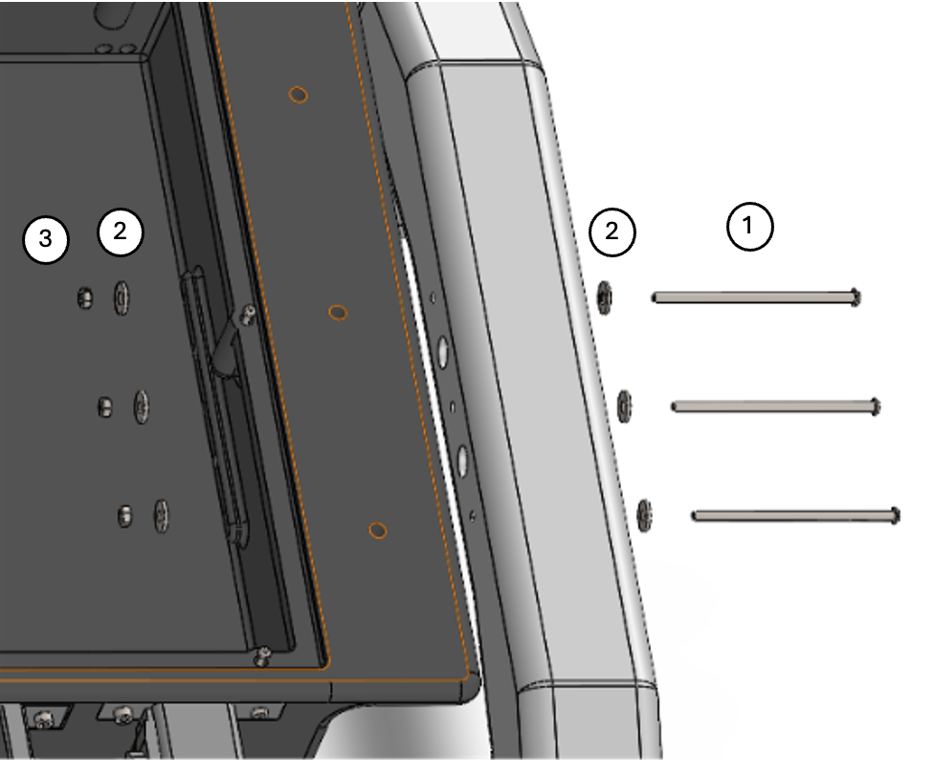
Figure 14: Suspension to Chassis Attachment Diagram

- M5 x 65 mm Socket Head Screws
- M3 15 mm Flat Penny Washers
- M5 Nyloc Nuts

The motor housings will be attached to the chassis using three M5 socket-head screws, nuts, and washers. Nuts will be used instead of heat-threaded inserts, as they ensure the force goes through the entire chassis side wall and remove the risk of cracking and inserts being pulled out of the material. Nyloc nuts will be used to prevent loosening due to vibration. Two 15 mm penny washers will be used per screw (one under the screw head and one above the nut) to spread the load over a wider area and prevent the nut from cutting into the PLA.
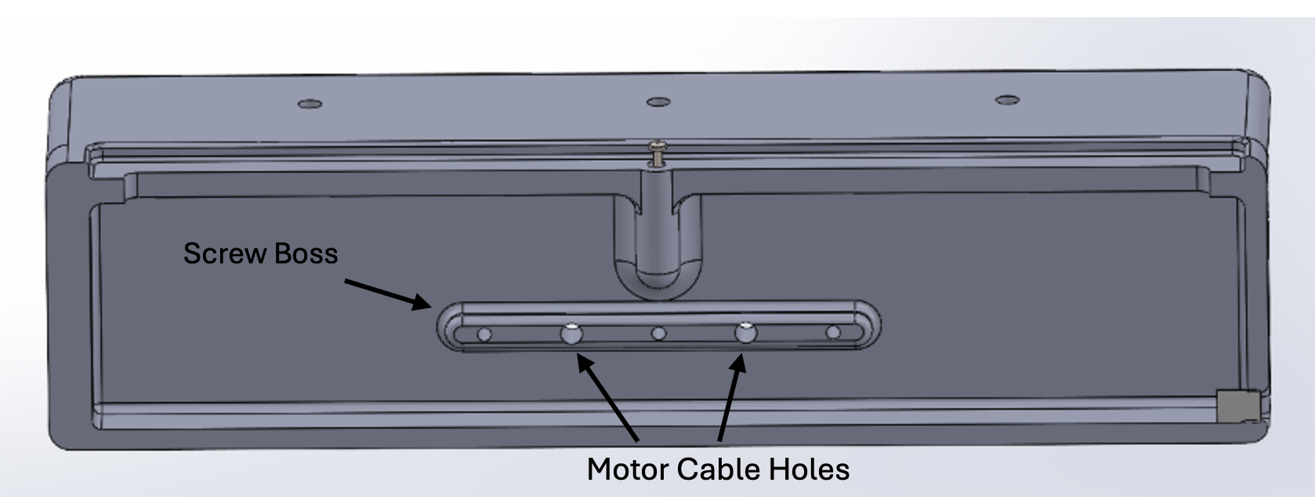Figure 15: Screw Boss Inside Chassis

Inside the chassis, there will be a solid screw boss (see Figure 15) to prevent cracking around the screws and increase strength. There are also larger circular holes in the chassis to allow the cables to be routed from the motors to the internal components without being exposed.

3.2.5 Wheels
Table 8: Mobility System Evaluation Matrix
Parameter | Weight | Dual Track Config. |  | Quad Track Config. |  | 4 Wheels |  | 6 Wheels
 |  | Score | Total | Score | Total | Score | Total | Score | Total
Weight | 7 | 4 | 28 | 2 | 14 | 9 | 63 | 6 | 42
Cost | 8 | 4 | 32 | 1 | 8 | 9 | 72 | 2 | 16
Complexity | 7 | 3 | 21 | 1 | 7 | 9 | 63 | 5 | 35
Assembly Complexity | 3 | 3 | 9 | 2 | 6 | 8 | 24 | 6 | 18
Repairability | 6 | 2 | 12 | 4 | 24 | 8 | 48 | 7 | 42
Volume | 3 | 5 | 15 | 1 | 3 | 8 | 24 | 5 | 15
Traction | 7 | 9 | 63 | 8 | 56 | 6 | 42 | 7 | 49
Stability | 9 | 9 | 81 | 8 | 72 | 7 | 63 | 8 | 72
Efficiency | 5 | 8 | 40 | 6 | 30 | 6 | 30 | 4 | 20
Risk of failure | 9 | 1 | 9 | 4 | 36 | 9 | 81 | 10 | 90
 | Total | 310 |  | 256 |  | 510 |  | 399

After further consideration and evaluation of other concepts, we have decided to switch from a dual-track setup (selected in the PDR phase) to a four-wheel setup to reduce complexity, mass, and power requirements. Although a dual-track setup would provide the best traction and stability, it is at high risk of failure because the track is a single point of failure. In addition, it drastically increases mass and volume requirements, which would be better allocated to the chassis and arm. Four wheels were selected as the least expensive and most complex solution, while offering suitable traction, stability, and a reduced risk of failure.
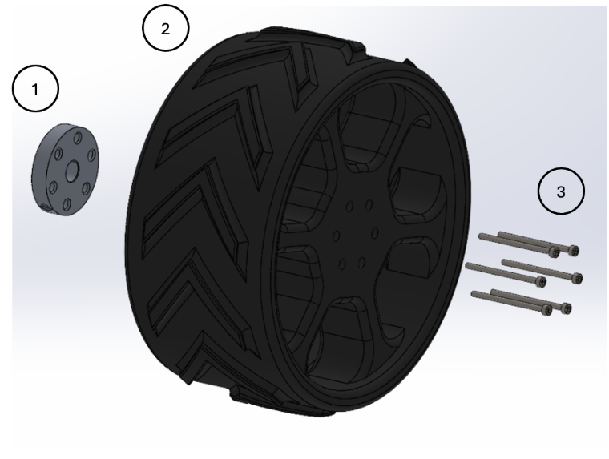
Figure 16: Wheel and mount annotated diagram

1. Metal Mounting Hub
2. 3D printed PETG wheel
3. 6 x M3 Socket Head Screws 25 mm length

The wheels will be 3D-printed in PETG, as it is much tougher than PLA and more resistant to cracking and fatigue. This is essential for the wheels to pass over rocks multiple times without damage. In addition, PETG is less heat-sensitive, ensuring the wheels remain strong even when sitting in the sun or heated by the motors. The wheels will have chevron-shaped grousers to generate traction and prevent slipping on gravel, as well as rounded edges to prevent them from catching on rocks. There will be reinforced spokes from the edge to the central hub to strengthen the wheels.
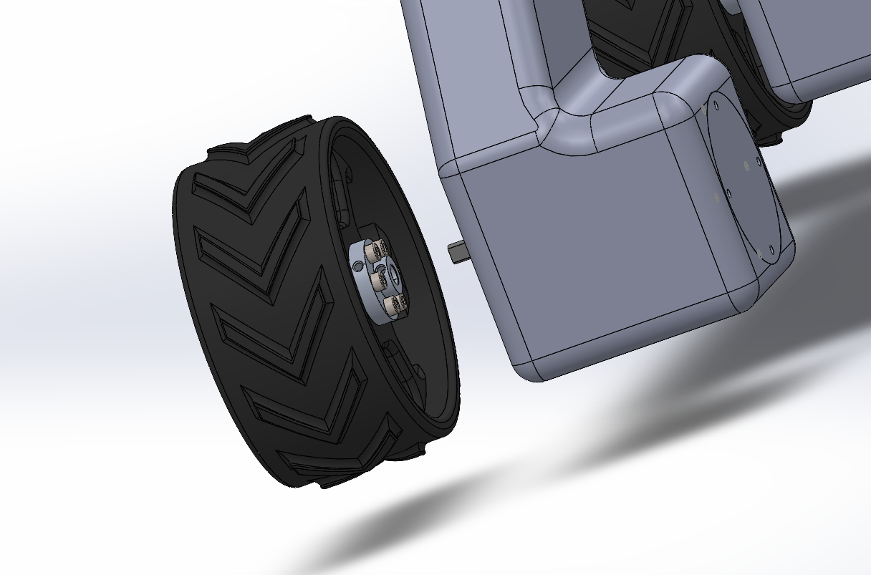
Figure 17: Motor to wheel mounting hub connection

Metal mounting hubs will be used to attach the motor to the wheels, as they prevent the wheels from slipping on the motor shaft and from cracking over time. There will be six M3 socket-head screws, 25 mm long, that screw into the mounting hub from the wheel. This also allows the wheels to be easily swapped in case of damage.

3.2.6 Material Selection
Table 9: Comparison of Different 3D Printer Filaments.
3D Printing Filament | Advantages | Disadvantages
PLA | PLA allows the plate to match the chassis structure's flexibility. Furthermore, PLA is more accessible, cheaper and easier to 3D print, allowing the design to be modified or repaired quickly. | PLA is brittle, so it can break or crack under high load or repeated stress.
PETG | Can handle higher loads and impact without cracking. It can withstand high temperatures, chemicals, and moisture resistance. | It can be difficult to print as it requires a high printing temperature. It can also scratch easily.
TPU | It can be stretched without breaking and can last longer under movement and friction. | It is difficult to 3d print; therefore, a slower printing speed is required to avoid printing issues. It has low rigidity and can deform under load.

Based on these advantages and disadvantages, the material for each component and the infill have been selected.
Table 10: 3D Printed Filament Selection
Filament | Components
PLA | Rover chassis (30% infill)
 | Chassis Lid (20% infill)
 | Servo camera mount (70% infill)
PETG | Wheels (40% infill)
 | Motor Housing (40% infill)

3.3 Electrical Design
To provide a rigorous definition of the rover's electrical architecture, the following pin-to-pin netlist details the exact physical connections across the system. This structured approach ensures absolute clarity for both power distribution and logic routing; it explicitly maps the physical source and destination of every critical signal. By systematically documenting these hardware interfaces, the table below guarantees that the integration aligns perfectly with the finalised design specifications.
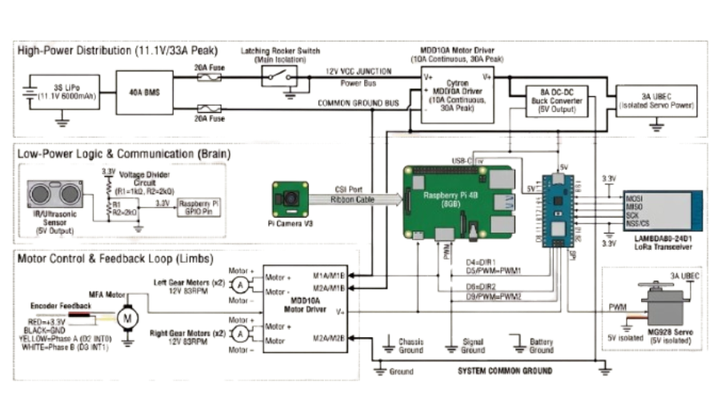
Figure 17: Schematic of Electrical Components

Table 11: Pin-to-Pin System Netlist
Subsystem | Source Component | Source Pin/Terminal | Destination Component | Destination Pin/Terminal | Signal / Notes
Power Distribution | 3S LiPo Battery | Pack Positive (+) | 40A BMS | B+ / Input | Raw 11.1V battery power
Power Distribution | 3S LiPo Battery | Pack Negative (-) | 40A BMS | B- / Input | System ground
Power Distribution | 40A BMS | P+ (Output) | SPST Latching Switch | Terminal 1 | Main 12V rail isolation
Power Distribution | SPST Latching Switch | Terminal 2 | Primary 12V Net | VCC Junction | Switched 12V to the system
Power Distribution | Primary 12V Net | VCC Junction | MDD10A Motor Driver | B+ | Motor power supply
Power Distribution | Primary 12V Net | VCC Junction | 8A DC-DC Buck Converter | IN+ | Main logic power source
Power Distribution | Primary 12V Net | VCC Junction | 3A UBEC Step-Down | IN+ | Isolated servo power
Logic Power | 8A DC-DC Buck Converter | OUT+ (5V) | Raspberry Pi 4B | 5V GPIO Pin | 5V logic supply
Logic Power | 8A DC-DC Buck Converter | OUT+ (5V) | Arduino Nano | 5V Pin | 5V logic supply
Logic Power | 8A DC-DC Buck Converter | OUT+ (5V) | IR Sensors (x3) | VCC | 5V sensor supply
Servo Power | 3A UBEC Step-Down | OUT+ (5V) | MG92B Pitch Servo | VCC (Red Wire) | 5V isolated supply
Motor Control | Arduino Nano | D4 | MDD10A Motor Driver | DIR1 | Left motor direction
Motor Control | Arduino Nano | D5 | MDD10A Motor Driver | PWM1 | Left motor speed
Motor Control | Arduino Nano | D6 | MDD10A Motor Driver | DIR2 | Right motor direction
Motor Control | Arduino Nano | D9 | MDD10A Motor Driver | PWM2 | Right motor speed
Drivetrain | MDD10A Motor Driver | M1A, M1B | Left Gear Motors (x2) | Motor+, Motor- | High-current drive output
Drivetrain | MDD10A Motor Driver | M2A, M2B | Right Gear Motors (x2) | Motor+, Motor- | High-current drive output
Encoder Feedback | Left Motor Encoder | Phase A | Arduino Nano | D2 (INT0) | Left rotation tracking
Encoder Feedback | Left Motor Encoder | Phase B | Arduino Nano | D8 | Left direction tracking
Encoder Feedback | Right Motor Encoder | Phase A | Arduino Nano | D3 (INT1) | Right rotation tracking
Encoder Feedback | Right Motor Encoder | Phase B | Arduino Nano | D7 | Right direction tracking
Telemetry (LoRa) | Arduino Nano | D11, D12, D13 | LAMBDA80 2.4GHz | MOSI, MISO, SCK | SPI data bus
Telemetry (LoRa) | Arduino Nano | D10 | LAMBDA80 2.4GHz | CS (Chip Select) | SPI active state
Sensor Logic | IR Sensors (x3) | OUT (Digital) | Voltage Divider Circuit | VIN (5V) | Logic level step-down
Sensor Logic | Voltage Divider Circuit | VOUT (3.3V) | Raspberry Pi 4B | General GPIO Pins | Safe obstacle detection
Visualization | Raspberry Pi Camera 3 | Ribbon Cable | Raspberry Pi 4B | CSI Port | Live video stream

(Note: All component ground pins will be routed back to the common system ground rail to ensure stable logic signals across the hardware.)

3.3.1 Camera Selection
Following the preliminary evaluations, the single Raspberry Pi Camera Module was formalised as the primary optical sensor for the rover's navigation system. This hardware interfaces directly with the dedicated CSI port; it provides a reliable 5-megapixel resolution alongside standard 2D monocular vision. Both the stereoscopic depth camera and the standard USB webcam were permanently excluded from the final design architecture.
Table 12: Camera Decision Matrix
Feature | Option A: Single Raspberry Pi Camera (4B) | Option B: Stereoscopic Depth Camera | Option C: USB Webcam
Status | Selected | Alternative | Insufficient
Vision Type | 2D (Monocular): Flat image only. | Sees volume and depth. | 2D: Flat image; often high latency.
Latency | Very Low: Connects directly to the CSI port (GPU). | Low: Onboard processing. | High: Uses USB bus; lags on Pi.
Complexity | Low: Plug-and-play standard library. | Medium: Requires depth map interpretation. | Low: Plug-and-play.
Cost | Average (~£45). | High (~£150+). | Very Low (~£15).

The selected CSI module successfully sustains the dense data throughput required for the real-time Wi-Fi visualisation feed. During system integration, this direct hardware connection demonstrated the exceptionally low latency strictly required for remote piloting. Furthermore, its native plug-and-play compatibility with standard software libraries minimised development overhead; it proved highly resilient under continuous operational testing. This finalised configuration guarantees the rover will effortlessly meet the mission parameters for both image collection and remote transmission.

3.3.2 Battery Selection
Since the drive motors have a nominal voltage of 12V, the closest and most efficient option for a LiPo power source is a 3S (11.1V) configuration (unmannedtechshop.co.uk). A fully charged 3S LiPo battery reaches 12.6V, providing the high torque needed to push the 4kg rover through heavy sand without over-volting and damaging the sensitive motor drivers. Operating at this voltage allows the motors to function near their peak efficiency. This ensures the system delivers the full 45kg·cm of torque required for obstacle clearance while keeping overall heat generation manageable.
To determine the total energy required for the rover, the following formula is utilised to calculate the battery capacity:
$$Battery Capacity=\frac{Current \left(A\right) × Time (Hours)}{Efficiency }$$

Table 13: Required Currents for Each Component
Hardware | Average Current (A) | Peak Current (A)
Raspberry Pi 4B | 1.2A | 3.0A
MG92B Servo (Camera Pitch) | 0.3A | 1.2A
12V 83RPM Motors (x4) | 8.0A (Heavy Sand) | 28.0A (Stall)
Other Hardware (LoRa, IR, etc.) | 0.5A | 0.8A
Total Requirements | 10.0A | 33.0A

For a standard 30-minute trial, the continuous current is estimated at 10.0A to account for heavy sand resistance. The trial time is 0.5 hours. An efficiency safety factor of 0.8 is applied to respect the 80% discharge rule.
$$Required Capacity= \frac{10A ×0.5h}{0.8}=6.25Ah$$
To satisfy this 6250mAh requirement, the design utilises two 5200mAh 80C batteries connected in parallel. This configuration yields a combined capacity of 10400mAh, comfortably exceeding the operational minimum.
By matching the capacities and discharge ratings precisely, the internal resistance remains balanced across the circuit. This parity prevents reverse cross-charging during load fluctuations, mitigates overheating risk, and ensures a safe power delivery system.

3.3.3 Battery Safety
To maintain operational safety, the lithium-ion power supply is protected by a multi-layered strategy that prevents deep discharge and thermal instability. The critical operating boundaries for the battery configuration are summarised below:
Table 14: Battery Critical Operating Boundaries
Aspect | Min | Min Consequence | Max (v)
Voltage per cell | 3.0 v | Permanent capacity loss, irreversible cell degradation | 4.2V
Total Pack Voltage | 9.0 v | Permanent damage to the pack, complete failure to recharge | 12.6V
Operating temperature | -20°C | Severe voltage drops, temporary loss of system function | 60°C
Continuous current | 0A | System remains completely inactive, no electrical flow | 40A

A dedicated Battery Management System (BMS) provides the first line of defence against electrical faults. This module monitors individual cell voltages to prevent over-charging and deep discharge, which can lead to permanent chemical degradation. To protect the internal circuitry during high-torque manoeuvres, the upgraded BMS enforces a 40A current limit and supports balance charging (A. Ashfraf, 2024). This robust capacity ensures the system can handle peak loads without unwanted cut-offs, whilst an appropriately rated inline fuse provides secondary redundancy against catastrophic short circuits.
To safely distribute power from the 11.1V battery network to the sensitive low-voltage electronics, the system incorporates two distinct step-down modules. A primary DC-DC buck converter regulates the 6V to 14V input range down to a stable 5V output and can supply up to 8A to the main control logic and peripheral sensors. A separate 3A UBEC step-down converter is dedicated exclusively to powering the camera servo. By isolating the servo power supply from the main electronic components, the design prevents sudden current spikes from causing voltage drops or systemic brownouts. Since the platform lacks an automated thermal shutdown, safety is maintained through a hard-wired Single Pole Single Throw (SPST) latching toggle switch. This kill switch is wired in series between the battery and the BMS; it allows the operator to physically disconnect the power rail if the rover exhibits abnormal behaviour or a fault is visually detected. By utilising a latching mechanism rather than a momentary one, the rover is guaranteed to remain in a safe, de-energised state until the operator performs a manual reset. This physical layer of protection ensures that even if the software fails or the wireless link drops, power can be cut off to mitigate the risk of fire alongside hardware damage.

3.3.4 Motor Selection
To drive the rover's drivetrain, the MDD10A dual-channel motor driver has been selected for its ability to handle high-current brushed DC motors. This controller delivers up to 10A of continuous current per channel, providing ample overhead for the GB37Y3530 motors, which exhibit a 7A stall current. With four motors in operation, the theoretical peak stall current of 28A is comfortably supported by the upgraded 40A Battery Management System. This ensures the rover will not experience systemic power failures during high-load scenarios. By utilising solid-state components, the driver ensures rapid response times alongside eliminating the mechanical wear associated with traditional relays.
The system architecture employs two motor drivers to independently manage the left and right wheel sets, simplifying the wiring harness and reducing overall control complexity. These drivers interface with the onboard microcontroller via PWM signals for precise speed regulation and support locked-antiphase or sign-magnitude control modes.
The MDD10A includes onboard manual test buttons, allowing for local testing of the drivetrain without requiring a microcontroller connection. This feature is particularly useful during assembly to verify motor polarity and gearbox functionality. To ensure the rover can navigate difficult terrain, the total tractive force was calculated against the maximum expected incline. The selected 131:1 gear ratio provides a balance of torque and speed that meets these mission requirements.

3.3.5 Distance Sensing
To maintain spatial awareness and prevent collisions during remote operation, the rover is equipped with a distributed array of Infrared (IR) proximity sensors. These modules were selected for their ability to provide instantaneous obstacle detection at close range, offering a reliable hardware-level safety net that complements the primary visual navigation system.
The detection suite consists of three IR Distance Sensors mounted on the rear and lateral sides of the chassis. This specific layout provides 270-degree coverage, protecting the rover's blind spots during reversing or pivoting manoeuvres (M. Borg, 2021). A forward-facing IR sensor was omitted from the design because the navigation camera provides a direct real-time feed of the rover's path. This enables the remote operator to visually identify frontal obstacles, making an additional electronic sensor redundant for the forward trajectory.
The IR sensors function by emitting infrared light and measuring the reflection from nearby objects to determine proximity. Unlike complex I2C or SPI sensors, these modules provide a straightforward digital output, simplifying integration with the Raspberry Pi and reducing processing latency.
- Logic Compatibility: Although the sensors are powered by a 5V supply, the digital output signals are passed through a voltage divider. This ensures the signal is stepped down to 3.3V to remain compatible with the Raspberry Pi's GPIO pins, preventing over-voltage damage to the controller.
- Reduced Complexity: By using a digital interface, the system avoids the overhead of managing multiple addresses on the I2C bus, ensuring that obstacle detection remains responsive even when the CPU is under heavy load from the LoRa communication and GUI tasks.
- Resource Efficiency: Limiting the array to three sensors conserves power and preserves available GPIO pins for other essential hardware, such as the motor encoders and the LoRa SPI interface.
By combining manual visual monitoring at the front with hardware-triggered proximity sensing on the sides and rear, the rover achieves a balance between comprehensive protection and efficient resource management (J. Bjurstrom, 2011). This dual-layered approach ensures the chassis is protected from impacts in all directions without necessitating an over-engineered sensor suite.

3.3.6 Communications
Visualisation Communications
To support the high data throughput required for live video streaming, the rover utilises the Raspberry Pi's built-in Wi-Fi module as the primary transmission method for visualisation. The forward-facing visual feed is captured directly by the camera module; this specific hardware generates a dense data stream that necessitates a robust wireless link. Meanwhile, critical motor commands and telemetry are handled independently by the 2.4GHz LoRa module. This bifurcated approach ensures that heavy video traffic cannot disrupt the low-latency control signals required for safe navigation.
Furthermore, all radio equipment in the UK is strictly regulated by Ofcom; all components utilised in this design carry the CE mark to ensure full legal compliance.
The Wi-Fi communication architecture is deliberately asymmetrical. The onboard Raspberry Pi is configured primarily to broadcast the camera data, while the base station equipment is dedicated exclusively to receiving it (N. A. Zaini, 2016). To ensure the most stable connection, testing will be conducted across both the 2.4 GHz and 5 GHz frequency bands. This evaluation allows the system to be optimised against common signal degradations, such as physical barriers or electromagnetic interference.
Movement Communications
During the Preliminary Design Review, an 868 MHz LoRa system was initially proposed to transmit control signals to the rover. Whilst this frequency offers an impressive range, subsequent analysis of the legal transmission constraints revealed a significant bottleneck; the 1% duty cycle regulated at this bandwidth would severely hamper real-time responsiveness. Under these restrictions, the radio must remain silent for most of the time to avoid congesting the spectrum (W. Pak, 2012). If a typical command packet requires a specific transmission window, the enforced cooling-off period would result in a multi-second latency between consecutive instructions.
$$Minimum Interval= \frac{Packet Airtime}{Duty Cycle Limit}$$
To ensure the rover functions reliably during remote operation, the communication architecture has been transitioned from 868 MHz to 2.4 GHz LoRa technology. By utilising the LAMBDA80-24D module, the system bypasses these restrictive timing windows, enabling a continuous stream of telemetry and motor control data.
The 2.4GHz spectrum provides the rover with higher data throughput while maintaining the robust modulation benefits characteristic of LoRa. Although signals at this frequency may be more susceptible to diffraction around obstacles, the module remains highly effective in the intended operational environment (G. Hochet, 2024).
The adoption of the 2.4GHz variant ensures a stable link even in electromagnetically noisy environments. Empirical testing has confirmed that the rover maintains a reliable connection without a direct line of sight, successfully processing packets at distances exceeding 30m in indoor settings. This consistent connectivity ensures that the remote operator always retains full authority over the vehicle’s movements. High-speed data transfer between the radio and the primary logic controller is facilitated by the SPI bus, which minimises latency during critical manoeuvres.
To provide absolute redundancy against severe RF interference or catastrophic hardware failure, a physical tether serves as the ultimate failsafe. If all wireless links are compromised by unpredictable external factors, the rover is equipped to transition to a wired Ethernet connection. This alternative communication capability guarantees that the remote operator can bypass congested spectrums to regain direct control. The inclusion of this wired backup ensures the mission can continue safely even if the primary wireless architecture completely fails.

3.4 Software Design

3.4.1 Overview
The software infrastructure is designed to facilitate the remote operation of the rover while ensuring high-integrity data acquisition and mission-critical safety. The system architecture is split between the onboard Raspberry Pi and a base station laptop, which work in tandem to manage real-time locomotion and complex vision processing. On the rover side, the software prioritises responsive control and hardware health by utilising dedicated modules for command processing, motor regulation, and continuous telemetry monitoring. These onboard systems are complemented by a robust communications manager that maintains the wireless link and provides a wired Ethernet fallback for contingency operations.
At the base station, the software provides the operator with a comprehensive interface that integrates a low-latency video feed with real-time status dashboards for full situational awareness. A key feature of this environment is the intelligent vision pipeline, which assists the operator by automatically detecting and decoding QR codes from high-resolution captures when specific quality thresholds are met. To support post-mission analysis, the system includes a mission management module that organises all captured images and decoded outputs into a structured format with precise timestamps. Throughout the mission, the software adheres to strict performance and safety requirements, including maintaining control latency below 200 milliseconds and implementing automatic heartbeat timeouts to ensure the rover enters a safe state in the event of a communication failure.

3.4.2 Development approach
The approach to developing the system centres on a lightweight, modular architecture that avoids the overhead and complexity of ROS while still supporting real-time control, autonomy, and reliable communication. Instead of ROS, the rover uses a custom microservices-style architecture implemented using Python, with each subsystem running as an independent process on the Raspberry Pi. These processes communicate through well-defined interfaces using shared memory, TCP sockets and asynchronous message queues.
This approach gives full control over performance, reduces latency, and ensures the system remains understandable and maintainable for all team members.

3.4.3 Architectural Philosophy
The software stack is designed around four main principles. Including;
- Modularity: each subsystem (which includes locomotion, perception, networking, and autonomy) runs as an independent Python module or background service to ensure faults are isolated, debugging is much simpler, components can be developed in parallel, and updates do not break unrelated systems.
- Low-latency communication: instead of ROS topics, we used apps like ZeroMQ for high-speed message passing, AsyncIO TCP sockets for command and control, and shared memory buffers for camera frames. This would help to keep latency extremely low, which is essential for teleoperation.
- Cross-platform ground control: the suggested systems for the ground control are Tauri and Rust, as they provide native performance, low memory usage, cross-platform compatibility and secure WebSocket communication.
- Deterministic behaviour: all timing-critical tasks (motor-control and sensor polling) run in dedicated threads or asynchronous loops with fixed update rates.

3.4.4 Software Stack
Onboard (Raspberry Pi 4B)
- Python 3.11
- OpenCV for camera and QR detection
- Pyzbar for decoding
- ZeroMQ for interprocess messaging
- AsyncIO for networking
- Pigpio for motor PWM control
- systemd services to auto-start each module on boot.

Ground Station
- Tauri
- Rust
- WebSocket client
- Gamepad API for Xbox controller input
- FFmpeg-based video decoding
- Real-time telemetry dashboard.

3.4.5 Development workflow
Phase 1 – Module development
Each subsystem is developed independently: motor controller, camera pipeline, QR detection, networking server, and telemetry module. Every module would include unit tests and simulated inputs.
Phase 2 – Integration via message passing
Modules are connected using ZeroMQ sockets: PUB/SUB for telemetry, REQ/REP for commands and PUSH/PULL for camera frames. This creates a clean, testable interface between components.
Phase 3 – Simulation and Bench testing
Before the hardware integration, the camera pipeline is tested with prerecorded video, the motor controller is tested with virtual PWM outputs, and networking is tested with artificial latency and packet loss.
Phase 4 – Hardware in the Loop
Here, modules are deployed on the Pi and tested with real motors, a real camera, real sensors, and real Wi-Fi conditions.
Phase 5 – System Level Testing
Full rover tests include teleoperation, QR detection, obstacle sensing, communication-loss recovery, and vibration robustness.

3.4.6 Advantages of this Approach
- Lower complexity: No ROS installations required, no DDS (Data Distribution Services) middleware, no launch files required.
- Higher performance: Direct control over threads, buffers and sockets,
- Better debugging: each module can be run, logged and tested independently.
- More accessible: team members with Python experience can contribute immediately without having to learn ROS.
- Customizable: architecture can be tailored to rover constraints and mission needs.

3.4.7 Link to GitHub Repository
A dedicated GitHub repository has been created to support the rover's software development lifecycle. Although the rover software has not been implemented, the repository serves as the central location for planning, documentation, prototype scripts, and future code development. As the project progresses beyond the CDR stage, all the software modules, testing tools and configuration files will be added to this repository.
GitHub Repository: https://github.com/ORTadvance/Rover.git
Planned Repository Structure
The repository will be organised to support modular development and clear traceability:
- /docs/ - contains design documents, communication protocol specifications, software architecture diagrams and planning notes.
- /onboard/ - will contain the Python modules for motor control, camera processing, QR detection, and networking once development begins.
- /ground_station/ - will store the Tauri + Rust ground control application source code.
- /config/ - will include configuration files such as calibration values, communication settings and system parameters.
- /tests/ - will contain unit tests, simulated sensor data, and validation scripts.
- /prototypes/ - early experimental scripts used during development (e.g. camera tests, motor PWM tests).

Test Procedure
To ensure the assembled rover meets all the requirements, a comprehensive test procedure has been developed. The procedure begins with individual subsystem tests, evaluating components such as the drive system, sensors, communication modules, and camera.
Following successful subsystem validation, integration testing is conducted to examine how the subsystems operate together. This step identifies any potential conflicts, timing issues, or unexpected interactions that could affect overall performance.
Prior to the competition, a full mock attempt will be performed, where the rover is operated continuously for 30 minutes. This test serves multiple purposes: it confirms that the rover can sustain the required duration without failure, provides practical verification of subsystem integration, and allows the team to become proficient and comfortable with real-time operation and control. Any issues identified during this test will be addressed promptly to ensure optimal performance on competition day. A complete breakdown of these testing methodologies, along with their specific success criteria, is detailed in the comprehensive table below.
Table 15: Complete Test Procedure
Subsystem | Test No. | Components | Test Objective(s) | Method | Requirements
Mechanical (M) | 1 | Wheels | Verify wheel structural strength | Apply a static load of 2 kg directly onto a mounted wheel for 60 seconds. Inspect the wheel afterwards. | -
 | 2 | Wheels | Verify wheel attachment | Attempt to manually rotate and pull each wheel after assembly. Check for excessive play in the wheel hub or shaft connection. | -
 | 3 | Chassis Frame | Test Structure Strength | Apply a static load of 5 kg to the top surface of the chassis for 60 seconds. Inspect for deformation. | -
 | 4 | Wheels | Evaluate wheel traction on uneven and loose terrain | Operate the rover on a gravel surface while applying forward motion. Also, drive the rover up a 15-degree slope. Observe wheel slip and rover mobility. | -
 | 5 | Wheels | Measure alignment | Command the rover to drive 5 m in a straight line on a flat surface. Measure deviation from the intended path. | -
 | 6 | Wheels, Motor Mounts | Assess wheel durability | Drive the rover continuously for 30 minutes on mixed terrain. Inspect wheel tread and motor mounts afterwards. | PP-002
 | 7 | Motors | Test control | Operate the rover in both forward and reverse directions at multiple speeds. Observe for irregular motion, drivetrain slip, or noise. | PP-002, PP-003
 | 8 | Chassis Frame | Test Impact resistance | Drive the rover over small obstacles (e.g., rocks or bumps approximately 2–3 cm in height). Inspect the chassis afterwards. | PP-002
 | 9 | Chassis Frame | Test torsional rigidity | Lift one corner of the rover approximately 5 cm off the ground and observe chassis deformation. | -
 | 10 | Chassis Lid | Verify access panel reliability | Open and close the chassis lid 10 times, then inspect the hinge/screw points for wear or loosening. | -
 | 11 | Camera Mount | Test range of motion | Rotate the camera through its full pitch range using the servo. Check for mechanical interference or cable strain. | ICS-001, P-001 (D), P-002 (D)
 | 12 | Camera Mount | Test the structural stability of the camera mount | Drive the rover over a rough surface while recording video from the camera. Inspect the mount and video footage. | PP-002, CC-005
 | 13 | Fasteners | Test vibration loosening | Mark bolts with a pen, drives for 15 minutes and rechecks if the marks have moved. | SM-003
 | 14 | Dust Protection | Verify chassis sealing | Expose the rover to a dusty environment (e.g., sand or fine soil) for 10 minutes while operating. Inspect the inside of the chassis afterwards. | -
Software (S) | 1 | Motor Control | Verify real-time control and motor response | Send drive commands via the Xbox controller and observe if the motors respond to forward and reverse inputs immediately. | PP-001, PP-002
 | 2 | Control Latency | Ensure end to end latency remains below 200 milliseconds | Measure the time gap between a controller input and the wheels' physical movement to confirm that it meets teleoperation targets. | CC-005, CC-001 (D)
 | 3 | Vision Stream | Ensure video lag is low enough for navigation | Compare a physical timer in front of the camera with the live display on the base station to confirm the delay is under 500 milliseconds | SAF-002, PP-004, CC-001 (D)
 | 4 | Safety Failsafe | Validate that the rover enters a safe state upon signal loss | Manually disconnect the base station transmitter while the rover is moving to verify the motors stop within the defined timeout. | SAF-003
 | 5 | QR Pipeline | Verify detection and decoding speed | Present a QR target to the camera and monitor the operator interface to ensure the processing rate stays at or above 5 frames per second | PP-001, PP-002, S-002 (D)
 | 6 | Range & Comms | Confirm wireless stability at maximum mission distance | Drive the rover to the 80-meter mark while monitoring the telemetry dashboard for any signal drops. | PP-002
 | 7 | Health Monitor | Verify accurate telemetry and fault reporting | Check the real-time display of battery voltage and system temperature to ensure the data matches physical sensor readings. | CC-005
 | 8 | Data Logging | Confirm successful storage of images and timestamps | Trigger a high-resolution capture and then inspect the mission output folder to verify the image is saved with the correct QR data. | CC-001, CC-003
 | 9 | Endurance | Validate continuous operation for the full mission window | Run all software modules simultaneously during a 30-minute field test on gravel to ensure no system crashes or reboots occur | ICS-001, ICS-002, PP-001 (D)
Electrical (E) | 1 | Initial Power-On and BMS Output | To verify the 40A BMS outputs stable voltage and balances the 3S LiPo cells. | Connect batteries in parallel to the BMS. Measure the output voltage across the main terminals using a digital multimeter. | -
 | 2 | Emergency Kill Switch (SPST) | To confirm the SPST latching switch successfully isolates the power rail. | Engage the drive motors to draw current. Manually toggle the SPST switch to the off position. | SAF-003
 | 3 | Motor Driver Actuation | To validate that the MDD10A modules accurately translate PWM signals into wheel rotation. | Send forward- and reverse-PWM signals from the microcontroller. Observe the motor response alongside measuring current draw. | PP-001, PP-002
 | 4 | Local Motor Driver Testing | To ensure the motors are wired with the correct polarity without relying on software. | Disconnect the microcontroller logic pins. Press the physical test buttons on the driver board. | -
 | 5 | IR Sensor Voltage Levels | To guarantee the IR sensor logic signals are stepped down safely for the Raspberry Pi. | Power the sensors from the 5V rail. Trigger the sensor with an obstacle whilst probing the voltage divider output. | CC-002 (D)
 | 6 | QR Code Detection | To verify that the camera is able to clearly capture small QR codes | Use the camera to take images of multiple different-sized QR codes, to verify that the images are clear enough to get the necessary data from. This will also be tested at varying distances to determine the camera's limits. | ICS-001,
 | 7 | 2.4GHz LoRa Control Link | To evaluate the continuous telemetry stream and command latency of the LAMBDA80-24D module. | Establish an SPI connection to the Arduino. Transmit continuous movement commands from the base station while recording the response time. | CC-005, CC-001 (D)
 | 8 | Wi-Fi Video Streaming | To assess the stability and throughput of the Raspberry Pi camera feed over a wireless network. | Initiate the camera stream from the rover. Monitor the feed on the base station receiver to evaluate the quality across both the 2.4GHz and 5GHz bands | CC-005, S-002 (D), S-003 (D)
 | 9 | Power Endurance | To confirm the battery is sufficient to allow the rover to operate continuously for 30+ minutes | Fully charge the batteries and then operate the rover continuously until it runs out of power. | SAF-004, PP-001 (D)
 | 10 | IR Sensors | To confirm that the IR sensors are able to detect objects in the rover’s path. | Drive the rover towards an object to verify that the IR sensors detect it and provide feedback to the operator. | CC-005,  CC-002 (D)

Concept of Operation
The rover is managed through a central laptop base station that utilises an Xbox controller to provide the operator with intuitive manual control over the vehicle’s movements. These precise steering inputs are translated into digital commands and transmitted over a dedicated 2.4GHz LoRa link, ensuring low-latency responsiveness during complex manoeuvres. To navigate gravel and rock terrain without a direct line of sight, the operator relies on a real-time dashboard that integrates a live video stream with critical telemetry data, including battery voltage and system health. This continuous visual feed is broadcast independently over a separate Wi-Fi network, preventing high-bandwidth video traffic from interfering with essential driving controls.
The primary operational window is engineered to sustain a thirty-minute deployment, supported by the dual 11.1V LiPo battery configuration. During this mission phase, the operator will drive the vehicle across the simulated surface to identify and decode designated QR targets. To guarantee mission success under adverse conditions, the operation includes strict contingency protocols; if unpredictable radio interference severely compromises the wireless networks, the team will transition to a hard-wired Ethernet tether to safely conclude the objective.

Compliance matrix
All requirements have been evaluated to confirm that our design meets them, as shown in the compliance matrix below.

Table 16: Compliance Matrix
No. | ID | Requirement | Subsystem | Priority | Status | Reference
1 | SM-001 | The integrated rover shall have a combined mass of no more than 5kg. | Mechanical | MUST | MET | 3.1.1 Mass and Volume Requirements
2 | SM-002 | The rover shall be limited to a boxed volume envelope of 0.03 cubic metres. There are no specific dimension limits. | Mechanical | MUST | MET | 3.1.1 Mass and Volume Requirements
3 | SM-003 | The rover shall be designed to survive the launch vibration environment. The mass and volume of any adapter plates will be included in the calculation of Requirement ORT RS-SM-001 and Requirement ORT RS-SM-002. | Mechanical | MUST | MET | Vibration Analysis – see Appendix F
4 | SM-004 | The rover shall be attached to the vibration system with the interface described in Appendix SOW-2. | Mechanical | MUST | MET | 3.2.3 Vibration Table Interface
5 | SM-005 | The integrated rover system shall be statically stable in all directions to an angle of at least 30 degrees. | Mechanical | MUST | MET
6 | SM-006 | The rover shall have a minimum number of 3 M5 bolts to interface with the vibration bed. | Mechanical | MUST | MET | 3.2.3 Vibration Table Interface
7 | PP-001 | The Rover shall use a form of locomotion that does not require a significant atmosphere (i.e. no aircraft). | Mechanical | MUST | MET | 3.2.5 Wheels, 3.3.3 Motor Selection, Test Procedure M4, M5, M6, M7
8 | PP-002 | The rover shall be able to traverse an unknown surface of gravel and rocks. Rock dimensions range from a vertical height of between 5 to 40 cm, with a nominal diameter range of 5 to 30 cm. The rock distribution should be considered random. The maximum incline of the slope is approximately 15 degrees. | Electrical | MUST | MET | Test Procedure M4
9 | PP-003 | The expected distance of travel that the rover will have to cover during the test is 60 m in total. Adding a safety margin to this value is recommended. | Electrical | MUST | MET | 3.3.2 Battery Selection, Test Procedure M6, E9
10 | PP-004 | The rover must have sufficient power to enable 30 minutes of on-gravel operations. | Electrical | MUST | MET | 3.3.2 Battery Selection, Test Procedure E9
11 | ICS-001 | The rover shall have a method of taking images. | Electrical | MUST | MET | 3.3.1 Camera Selection, Test Procedure E6, S8
12 | ICS-002 | The rover shall have a method of sending images taken to the Team such that the images are able to be displayed on a digital screen. | Electrical | MUST | MET | 3.3.5 Communications, Test Procedure S5, S8
13 | CC-001 | Communication between the operating base and the rover shall be wireless. No time delay is added to the communication system. | Electrical | MUST | MET | 3.3.5 Communications
14 | CC-002 | An alternative communications capability shall be included. This may be wired (e.g. Ethernet) and will only be used if unpredictable external factors influence the testing (such as interference). An Ethernet cable will be available for use on the day. | Electrical | MUST | MET | 3.3.5 Communications
15 | CC-003 | All wireless communications must use UK legal frequencies and should be used responsibly. | Electrical | MUST | MET | 3.3.5 Communications
17 | CC-005 | The team shall be able to operate the rover using its onboard navigation systems only. | Electrical | MUST | MET | 3.3.5 Communications, Test Procedure S5, S8
18 | SAF-001 | No exposed point or area of the vehicle shall carry a live voltage > 12V at any point during operation for the rover. | Electrical | MUST | MET | 3.3.2 Battery Safety
19 | SAF-002 | The vehicle’s batteries shall be protected from the following conditions - over voltage, under voltage, over current, over, temperature, short circuit and reverse connection. Lead Acid batteries are not allowed. The batteries shall be removable. Battery good practice shall be followed. In the case of LiPo batteries, charge bags and a CE marked LiPo charger shall be used. | Electrical | MUST | MET | 3.3.2 Battery Safety
20 | SAF-003 | The rover shall have an external and easily accessible manual hardware kill switch that isolates battery power from the rest of the rover. | Electrical | MUST | MET | 3.3.2 Battery Safety, Test Procedure E2
21 | SAF-004 | Rovers with autonomous capabilities shall be highlighted to the judges to ensure that sufficient safety measures are in place. | Electrical | MUST | NOT MET | Once the rover software is complete this will be done if autonomous capabilities are developed.
22 | SAF-005 | Motors & motor connections must be protected from the environment to reduce the risk of exposed wires in the event of a collision. | Electrical | MUST | MET | 3.2.4 Motor Housing and Suspension
D1 | P-001 (D) | The camera not be fixed to the chassis i.e. the camera attitude is undefined by the chassis orientation alone. | Mechanical | SHOULD | MET | 3.2.1 Camera Mount, Test Procedure M11
D2 | P-002 (D) | The camera system shall allow the camera to view QR codes 20cm above and below the rover. | Mechanical | SHOULD | MET | 3.2.1 Camera Mount, Test Procedure M11
D3 | ICS-001 (D) | The onboard camera shall have sufficient resolution to reliably capture QR codes of different sizes at a range of distances | Electrical | MUST | MET | 3.3.1 Camera Selection, Test Procedure E6
D4 | ICS-002 (D) | The camera will have the ability to autofocus to ensure QR codes are visible from different distances in different lighting conditions. | Electrical | SHOULD | NOT MET | The Raspberry Pi 4 camera does not have autofocus, however it will be able to view QR codes at different distances and in different lighting conditions. Test Procedure E6
D5 | CC-001 (D) | The communication system shall maintain image transmission with a latency low enough to allow the rover to be effectively operated. | Electrical | MUST | MET | 3.3.5 Communications, Test Procedure S2, S3
D6 | CC-002 (D) | The rover shall include proximity sensors to detect obstacles and provide feedback to the operator. | Electrical | MUST | MET | 3.3.4 Distance Sensing, Test Procedure E10
D7 | PP-001 (D) | The system shall have enough power to continuously transmit data and images for the full mission duration (> 30 mins), with an additional safety margin of 15 mins. | Electrical | MUST | MET | 3.3.2 Battery Selection, Test Procedure E9
D8 | S-001 (D) | Support autonomous operation by integrating wheel encoders, camera and proximity sensors to enable closed-loop motion control, obstacle detection and basic path planning without continuous manual input. | Software | SHOULD | MET | 3.3.3 Motor Selection, 3.3.4 Distance Sensing, Test Procedure E10
D9 | S-002 (D) | Provide real-time camera handling and QR code detection at a frame rate sufficient for autonomous navigation and target detection in the ORT environment. | Software | SHOULD | MET | 3.3.5 Communications, Test Procedure S5, S8
D10 | S-003 (D) | Exchange commands and telemetry (including navigation status and decoded QR data) with the ground station over the chosen wireless link, allowing supervision, mode switching between teleoperated and autonomous modes, and logging for later analysis. | Software | MUST | MET | 3.3.5 Communications, Test Procedure S8
D11 | S-004 (D) | Use a modular software structure (separate processes or modules for navigation, vision and communications) to simplify testing and allow multiple team members to work on different features in parallel. | Software | SHOULD | MET | 3.4.3 Architectural Philosophy

Acknowledgements
We would like to express our gratitude to Joshua Amar, Head of QMSEDS, for securing funding and supporting our participation in this competition. We are also grateful to UKSEDS for their continued support throughout the project, and to our academic supervisor, Dr. Angadh Nanjangud, for his invaluable guidance. Finally, we appreciate the UKSEDS volunteers for their assistance and for providing us with the opportunity to take part in this competition.

References
A. Ashraf (2024). Advanced battery management system for electric vehicles with modular battery packs. University of Birmingham.
G. Hocket, et al. Feasibility and performance of a LoRa 2.4 GHz network.
Gluegun.com. The Complete Guide to Loctite Super Glue. [Online] Available at: https://www.gluegun.com/blogs/news/the-complete-guide-to-loctite-super-glue?srsltid=AfmBOop7BuYIrQmE0CakBsaOujQOpfYGQWNFFQAxKkP9DpJWoBM5Tk3U
J. Bjurstrom. (2011). Vision-Based Rover Navigation Demonstrator. [Online] Available at: https://www.diva-portal.org/smash/record.jsf?pid=diva2%3A1019054&dswid=8337
M. Borg. (2021). Autonomous Amphibious Robot Navigation through the Littoral Zone. University of Ontario Institute of Technology.
NASA. Artemis II. [Online] Available at: https://www.nasa.gov/humans-in-space/artemis/
N. A. Zaini, et al. (2016). Remote monitoring system based on a Wi-Fi controlled car using Raspberry Pi. 2016 IEEE Conference on Systems, Process and Control (ICSPC).
ThePiHut.com. Pololu Universal Aluminium Mounting Hub for 6mm Shafts - M3 Holes (2-Pack). [Online] Available at: https://thepihut.com/products/pololu-universal-aluminium-mounting-hub-for-6mm-shafts-m3-holes-2-pack
ThePiHut.com. (2026). TowerPro Servo Motor - MG92B 360° (Metal Gear). [Online] Available at: https://thepihut.com/products/towerpro-servo-motor-mg92b-metal-gear-360
unmannedtechshop.co.uk. SMC HCL-HP 22.2V-5200mAh-80C Flight Pack. [Online] Available at: https://www.unmannedtechshop.co.uk/products/smc-hcl-hp-22-2v-5200mah-80c-flight-pack
W. Pak, et al. (2012). Duty cycle allocation to maximise network lifetime of wireless sensor networks with delay constraints. Wireless Communications and Mobile Computing. Vol. 14, Iss. 6

Appendices

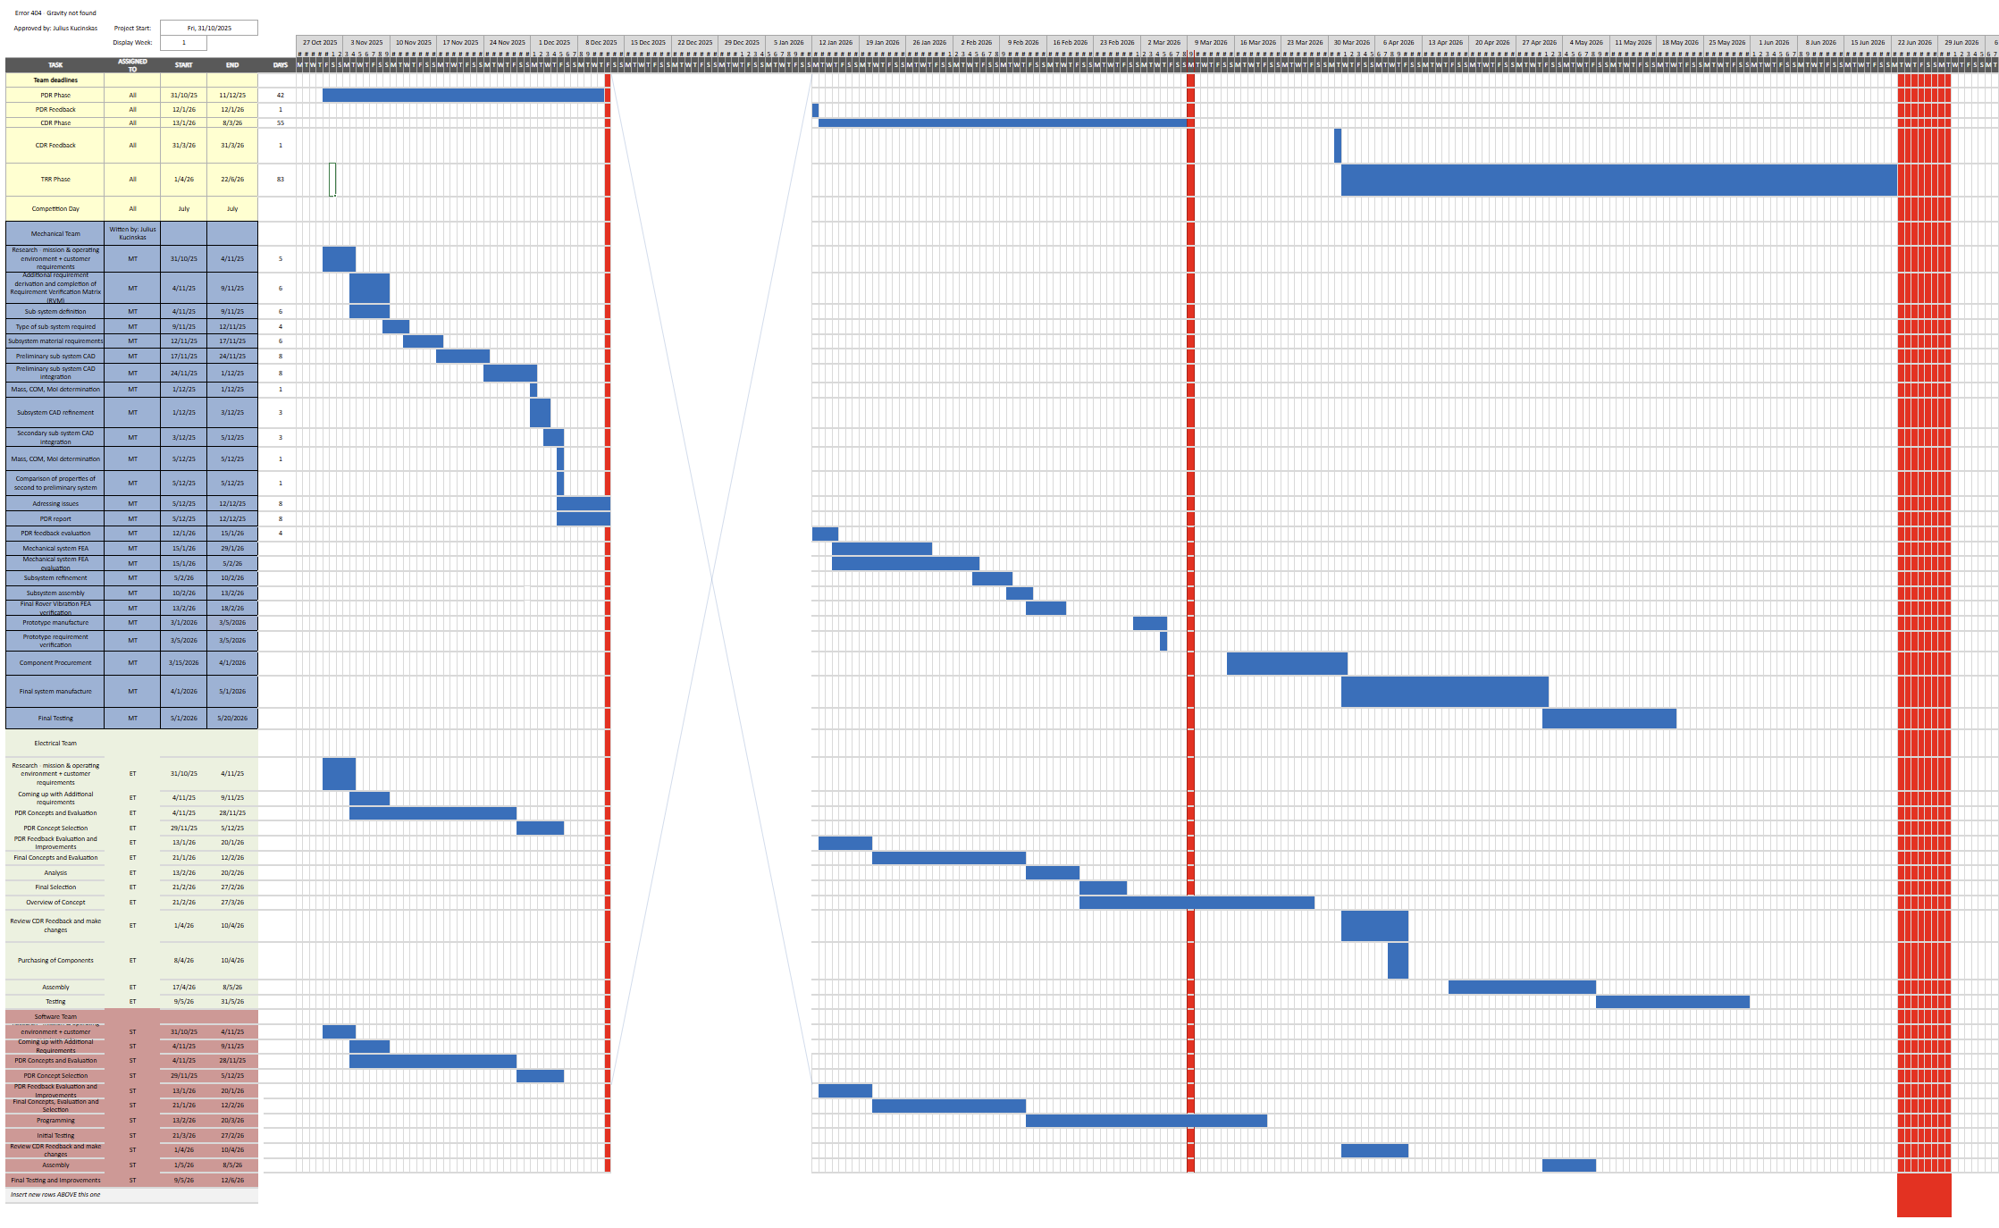
Appendix A: Complete Schedule

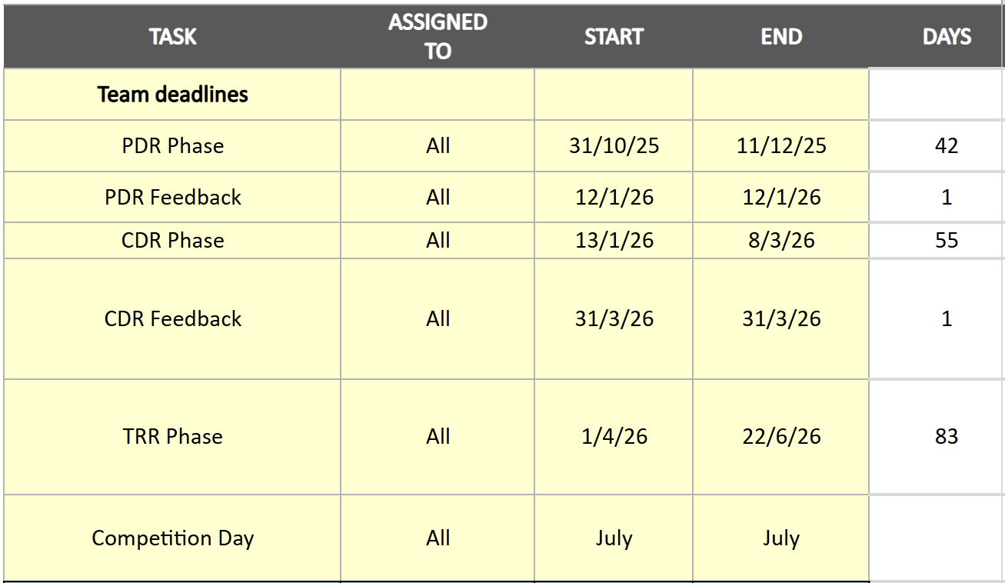
Figure A1: Complete Schedule

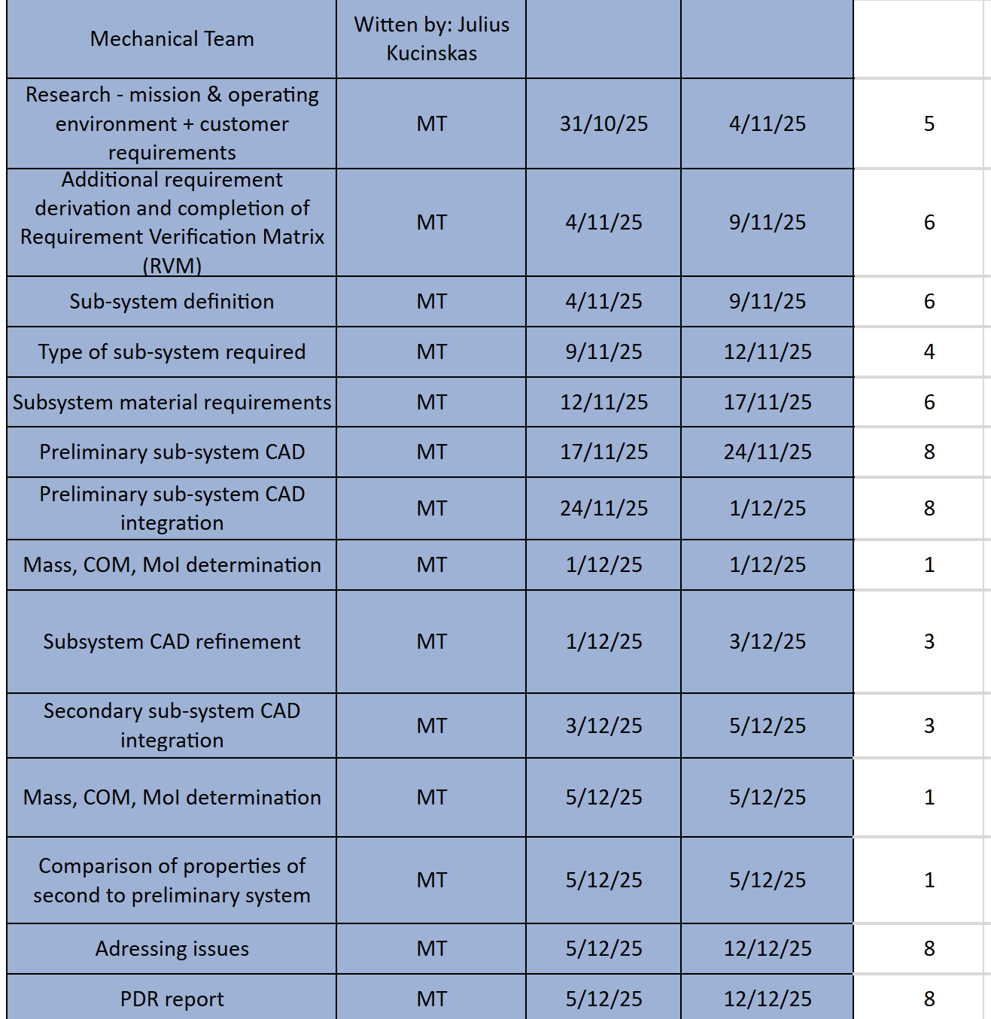

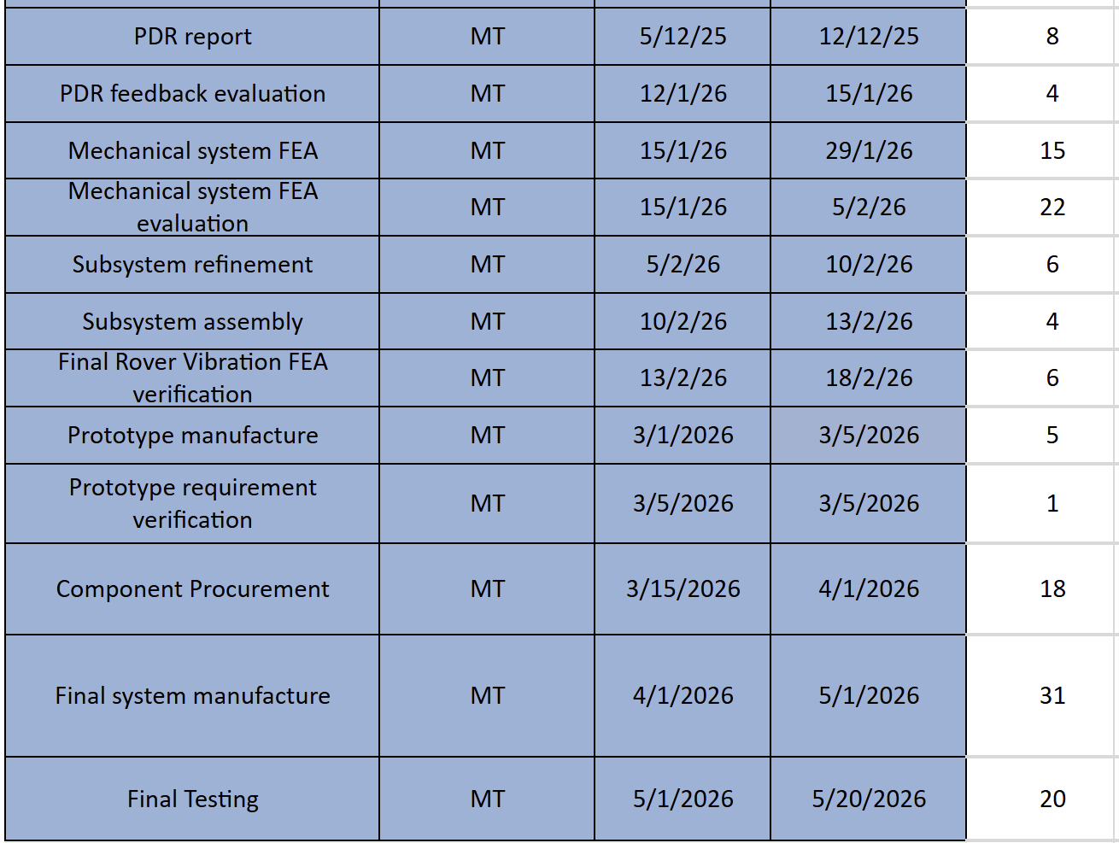

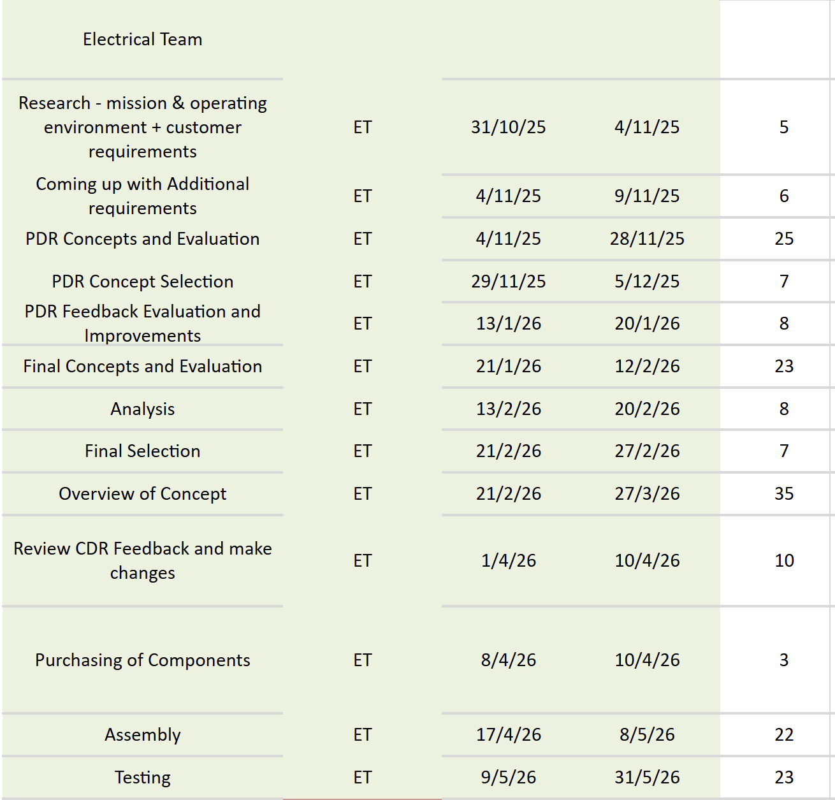

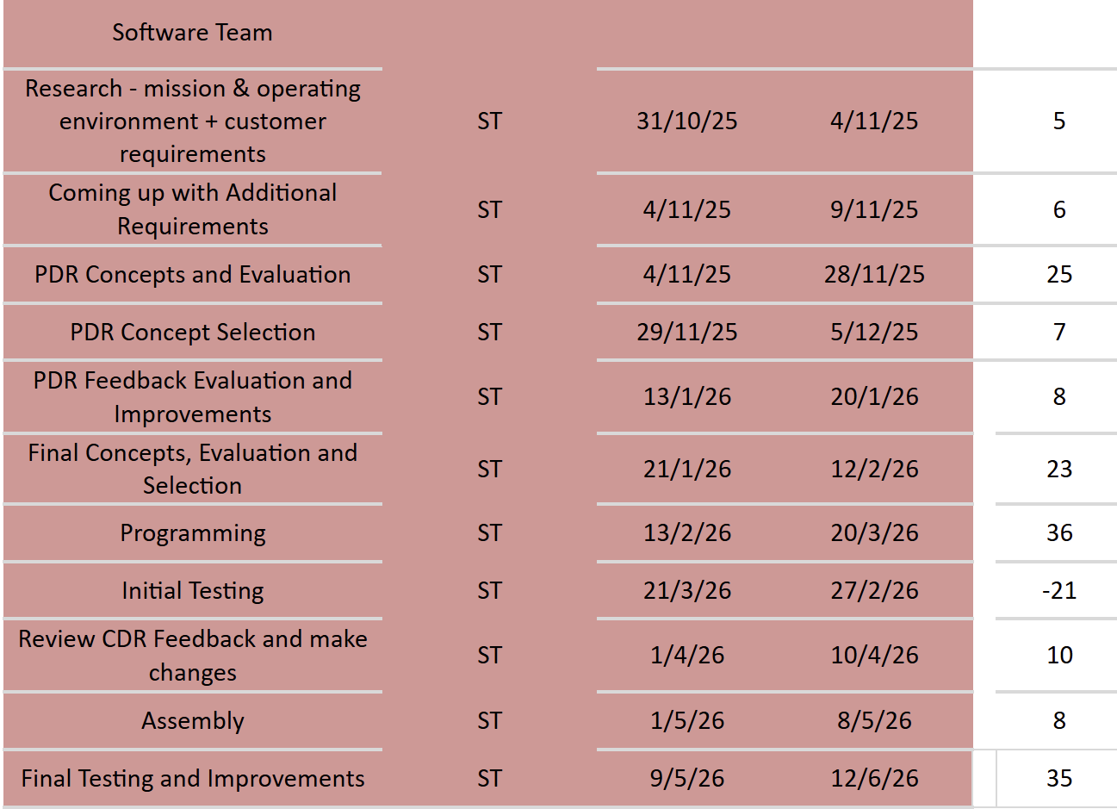

Figure A2: General Work Breakdown Structure for Each Sub-team

Table A1: Mechanical Team WBS
Task ID (-Nr) | Task Name/Description | Description/Comments | Assigned Group/Person | Start Date | Due Date | Task Deliverable
G-001 | Bolt interface test/Heat insertion testing | Series of 3D prints and M3 screw interface testing. Reusability to test. PLA from other manufacturer to be bought and tested in case initial testing unsucessful | Kyra | 1/29/2026 | 2/12/2026 | Brief CDR section evaluating decision, outcome and its significance on the system
ODS-001 | Wire bypasses | CAD component alternations and documentation in the CDR. | Julius | 1/29/2026 | 2/2/2026 | CAD, CDR evaluation
ODS-002 | Re-evaluation of mass and moment of inertia from which servo models can be verified | Performed in Solidworks | Julius | 1/29/2026 | 2/2/2026 | CDR evaluation
ODS-003 | CAD of Simple RC servo to control the pitch axis of the camera | If needed, though less servo torque than original design and number of arms needed is 2. CDR documentation | Julius | 2/2/2026 | 2/7/2026 | CAD, CDR evaluation
ODS-004 | ODS CAD sensor integration (motion and collision sensors). No motion sensors | What sensors, are they compatible with the rasberry pi? Sensor model needed and number of sensors and their positions. How and where are we setting up the tests?Anything else to be aware of? | N/A | 2/7/2026 | 2/14/2026 | CAD, CDR mention - why these positions have been chosen
C-001 | Chassis door to internal components. Implementation of kill switch and latch for ethernet cable | In order to stow/remove batteries. Kill switch is external. | Kyra | 1/29/2026 | 2/12/2026 | CAD. Very brief CDR mention
G-002 | Chassis -ODS interface debris insulation and general servo insulation/covers | Labyrinth CAD. | Julius | 1/29/2026 | 2/5/2026 | CAD, CDR evaluation
D-001 | CAD: Chassis motor integration + drive train + debris insulation | Motor mounts need to be finished and no conflicts between components inside the chassis | Younus | 2/5/2026 | 2/12/2026 | CAD, CDR evaluation
W-001 | Complete wheel CAD + print one wheel | Wheels would be preferable over virtually all circumstances at this stage. Complete wheel CAD - this includes interface between the motors as well. Currently, I recommend M3 screws. Check sandproofing | Kyra | 1/29/2026 | 2/5/2026 | CAD, CDR evaluation
S-001 | Full Suspension CAD | CAD, evaluate how big of an effect the suspension has on energy dissipation? Ansys simulation needed to convince. Exact CAD depends on wheels and chassis which need to be completed first | Younus | 1/29/2026 | 2/5/2026 | CAD, CDR evaluation
MP-001 | Mounting plate CAD + 3D print | Requires the chassis to be fully complete to guarantee no conflicts between subsystems during their integration. Rover  must be mounted directly, without any additional components that do not exist  on the rover during nominal use. the  rover shall be bolted down onto the plate, bolts cannot be passed from  underneath the plate. | Asmitha | 2/5/2026 | 2/12/2026 | Prototype, tets analysis and evaluation mentioned in the CDR
ODS-005 | 3D print of ODS + chassis prototype | Door to be tested and this prototype will be used for the power transfer tests from the motors to the wheels | Julius | 2/12/2026 | 2/19/2026 | Prototype, CDR mention
ODS-006 | ELECTRONICS TO COMPLETE ODS - dynamic ODS and powertrain test. Test of all sensors and mounting plate interface | Some electronics need to be bought and integrated to test. Software control needs to be established. THIS INCLUDES TESTING OF ALL THE SENSOR MODELS! Components need to arrive by the 19th of February | Julius | 2/19/2026 | 2/26/2026 | Fully functional prototype and evaluation
G-003 | Vibration testing (FEA) | Test for the natural frequencies of the system and confirm that deviate significantly from the test frequencies of shaker table. What is the displacement at the shaker table frequencies and is this safe? | Julius | 2/19/2026 | 2/26/2026 | CDR evaluation
G-004 | Mechanical load testing (FEA) | Most likely Ansys - perhaps not even needed if ODS testing is successful but if there is sufficient time, good to identify points most likely to fail and add fillets etc. Then perform the analysis again, highlighting the impact of the improvements | Julius | 2/19/2026 | 2/26/2026 | CDR evaluation
D-002 | Test of motor control and power transfer to the wheels. Requires CAD and its print | Full print not needed, a motor needs to be bought by this stage and the drive train and wheel printed | Software team | 2/12/2026 | 2/19/2026 | CDR evaluation
G-005 | ALL requirement verification checks | If successful, can finalize the mechanical report. Needs very clear mention in the CDR that this evaluation has been completed | Everyone | 2/12/2026 | 2/28/2026 | CDR evaluation
ODS-007 | Lock mechanism for ODS | Stow/Unstow remotely | Julius | 1/29/2026 | 2/5/2026 | CDR evaluation
ODS-008 | Determination of TPU supports for the ODS arm through FEA | Ansys | Julius | 2/5/2026 | 2/12/2026 | CDR evaluation

Appendix B: Bill of Materials
Table B1: Bill of Materials
Subsystem | Comp. Name | Description | Vendor |  | Link | Unit Price (£) | Quantity | Total Price (£)
Mechanical | Camera Pitch Servo | MG92B | TowerPro |  | Link | 0 (Owned) | 1 | 0.00
 | PLA Filament | ELEGOO PLA+ Filament 1.75mm Black 1KG, PLA Plus Tougher and Stronger 3D Printer Filament, Dimensional Accuracy +/- 0.02mm, 1kg Cardboard Spool(2.2lbs) | Amazon | Link |  | 13.59 | 1 | 13.59
 | PETG Filament | ELEGOO Rapid PETG Filament 1.75mm Grey 1KG, High Speed Up to 600mm/s 3D Printer Filament Dimensional Accuracy +/- 0.02 mm, 1kg Cardboard Spool(2.2lbs) | Amazon | Link |  | 13.59 | 1 | 13.59
 | 500mm cable | Compatable with Raspberry pi 4 and Raspberry Pi Camera. Dimensions: 450mm x 16mm (approx.) | ThePihut | Link |  | 2.40 | 1 | 2.40
Electrical | Camera | Raspberry Pi Camera Module 3 | ThePihut |  | Link | 24.00 | 1 | 24.00
 | Sensors | IR sensor | Amazon | Link |  | 6.49 | 1 (set of 3) | 6.49
 | Processor | Raspberry Pi 4B | Amazon | Link |  | 69.45 | 1 | 69.45
 | Communication | LAMBDA80 LORA MODULE 2.4GHz | RF solutions | Link |  | 7.54 | 1 | 7.54
 | Batteries | LiPo (Lithium Polymer) | Amazon | Link |  | 37.00 | 2 | 37.0 (1 owned)
 | Motors | Metal DC Geared Motor w/Encoder | ThePihut | Link |  | 15.90 | 4 | 63.60
 | Motor Mounting Hub | Aluminium Mounting Hub for 6mm Shafts | ThePihut | Link |  | 12.50 | 2 | 25.00
 | Motor Driver | 10A 5V-30V 2-Channel DC Motor Driver | ThePihut | Link |  | 22.20 | 2 | 44.40
 | Kill Switch | SPST ON-OFF Latching Miniature Toggle Switch | ThePihut | Link |  | 1.5 | 1 | 1.5
 | BMS | 3S 40A Lithium Battery Protection Circuit Board with Balance Charging | Amazon | Link |  | 5.33 | 1 | 5.33
General | Microfibre Cloth | Microfibre Cloth (for cleaning sand off of the rover) | Generic |  | n/a | 0 (Owned) | 1 | 0
 | Paintbrush | Paintbrush (for cleaning sand off of the rover) | Generic | n/a |  | 0 (Owned) | 1 | 0
Screws and Fixings | Superglue | Loctite superglue | Generic |  | n/a | 0 (Owned) | 1 | 0
 | Velcro Tape | VELCRO® Brand | Stick On Tape | Cut-to-Length Strong Hook & Loop Self Adhesive Sticky Tape Perfect for Room Décor & Home, Office, Garage Use | Black | 20mm x 1m | Amazon | Link |  | 3.49 | 1 | 3.49
 | Zip Ties | Zip Ties | Generic | n/a |  | 0 (Owned) | 4 | 0
 | Chassis Lid Screws | M3 x 10mm Phillips Pan Head Machine Screws (DIN 7985H) - Stainless Steel (A2) | Accu | Link |  | 0.2 | 6 | 1.2
 | Heat Set Threaded Inserts | M3 5.7 mm Brass Heat Set Threaded Inserts | Accu | Link |  | 0.29 | 6 | 1.74
 | Vibration Table Screws | M5 x 20mm Full Thread Socket Cap Head Screws (DIN 912 / ISO 4762) - Stainless Steel (A2) | Accu | Link |  | 0.25 | 6 | 1.38
 | Vibration Table Washers | M5 x 15mm Penny Washers - Stainless Steel (A2) | Accu | Link |  | 0.2 | 6 | 1.2
 | Metal to Wheel Motor Hub Screws | M3 x 12mm Full Thread Socket Cap Head Screws (DIN 912 / ISO 4762) - Stainless Steel (A2) | Accu | Link |  | 0.1 | 24 | 2.4
 | Motor Hub and Camera Mount Nuts | M3 Hexagon Nylon Locking Nuts (DIN 985) - Stainless Steel (A2) | Accu | Link |  | 0.09 | 24 (Metal motor hub) + 5 (camera mount) = 29 | 2.61
 | Motor Mount Screws | M5 x 65mm Socket Cap Head Screws (DIN 912 / ISO 4762) - Stainless Steel (A2) | Accu | Link |  | 0.43 | 6 | 2.58
 | Motor Mount Washers | M5 x 15mm Penny Washers - Stainless Steel (A2) | Accu | Link |  | 0.14 | 12 | 1.68
 | Motor Mount Nuts | M5 Hexagon Nylon Locking Nuts (DIN 985) - Stainless Steel (A2-70) | Accu | Link |  | 0.18 | 6 | 1.08
 | Camera Mount Screws | M3 x 14mm Full Thread Socket Cap Head Screws (DIN 912 / ISO 4762) - Stainless Steel (A2) | Accu | Link |  | 0.28 | 5 | 1.4
 |  |  |  |  |  |  | Total | 334.25

Appendix C: Requirements
Table C1: Given Requirements (see ORT-RS)
No. | ID | Requirement | Subsystem | Priority
1 | SM-001 | The integrated rover shall have a combined mass of no more than 5kg. | Mechanical | MUST
2 | SM-002 | The rover shall be limited to a boxed volume envelope of 0.03 cubic metres. There are no specific dimension limits. | Mechanical | MUST
3 | SM-003 | The rover shall be designed to survive the launch vibration environment. The mass and volume of any adapter plates will be included in the calculation of Requirement ORT RS-SM-001 and Requirement ORT RS-SM-002. | Mechanical | MUST
4 | SM-004 | The rover shall be attached to the vibration system with the interface described in Appendix SOW-2. | Mechanical | MUST
5 | SM-005 | The integrated rover system shall be statically stable in all directions to an angle of at least 30 degrees. | Mechanical | MUST
6 | SM-006 | The rover shall have a minimum number of 3 M5 bolts to interface with the vibration bed. | Mechanical | MUST
7 | PP-001 | The Rover shall use a form of locomotion that does not require a significant atmosphere (i.e. no aircraft). | Mechanical | MUST
8 | PP-002 | The rover shall be able to traverse an unknown surface of gravel and rocks. Rock dimensions range from a vertical height of between 5 to 40 cm, with a nominal diameter range of 5 to 30 cm. The rock distribution should be considered random. The maximum incline of the slope is approximately 15 degrees. | Electrical | MUST
9 | PP-003 | The expected distance of travel that the rover will have to cover during the test is 60 m in total. Adding a safety margin to this value is recommended. | Electrical | MUST
10 | PP-004 | The rover must have sufficient power to enable 30 minutes of on-gravel operations. | Electrical | MUST
11 | ICS-001 | The rover shall have a method of taking images. | Electrical | MUST
12 | ICS-002 | The rover shall have a method of sending images taken to the Team such that the images are able to be displayed on a digital screen. | Electrical | MUST
13 | CC-001 | Communication between the operating base and the rover shall be wireless. No time delay is added to the communication system. | Electrical | MUST
14 | CC-002 | An alternative communications capability shall be included. This may be wired (e.g. Ethernet) and will only be used if unpredictable external factors influence the testing (such as interference). An Ethernet cable will be available for use on the day. | Electrical | MUST
15 | CC-003 | All wireless communications must use UK legal frequencies and should be used responsibly. | Electrical | MUST
16 | CC-004 | RF Equipment may be placed at the starting area. | Electrical | MUST
17 | CC-005 | The team shall be able to operate the rover using its onboard navigation systems only. | Electrical | MUST
18 | SAF-001 | No exposed point or area of the vehicle shall carry a live voltage > 12V at any point during operation for the rover. | Electrical | MUST
19 | SAF-002 | The vehicle’s batteries shall be protected from the following conditions - over voltage, under voltage, over current, over, temperature, short circuit and reverse connection. Lead Acid batteries are not allowed. The batteries shall be removable. Battery good practice shall be followed. In the case of LiPo batteries, charge bags and a CE marked LiPo charger shall be used. | Electrical | MUST
20 | SAF-003 | The rover shall have an external and easily accessible manual hardware kill switch that isolates battery power from the rest of the rover. | Electrical | MUST
21 | SAF-004 | Rovers with autonomous capabilities shall be highlighted to the judges to ensure that sufficient safety measures are in place. | Electrical | MUST
22 | SAF-005 | Motors & motor connections must be protected from the environment to reduce the risk of exposed wires in the event of a collision. | Electrical | MUST

Table C2: Additional Derived Requirements
No. | ID | Requirement | Subsystem | Priority
1 | P-001 (D) | The camera not be fixed to the chassis i.e. the camera attitude is undefined by the chassis orientation alone. | Mechanical | SHOULD
2 | P-002 (D) | The camera system shall allow the camera to view QR codes 20cm above and below the rover. | Mechanical | SHOULD
3 | ICS-001 (D) | The onboard camera shall have sufficient resolution to reliably capture QR codes of different sizes at a range of distances | Electrical | MUST
4 | ICS-002 (D) | The camera will have the ability to autofocus to ensure QR codes are visible from different distances in different lighting conditions. | Electrical | SHOULD
5 | CC-001 (D) | The communication system shall maintain image transmission with a latency low enough to allow the rover to be effectively operated. | Electrical | MUST
6 | CC-002 (D) | The rover shall include proximity sensors to detect obstacles and provide feedback to the operator. | Electrical | MUST
7 | PP-001 (D) | The system shall have enough power to continuously transmit data and images for the full mission duration (> 30 mins), with an additional safety margin of 15 mins. | Electrical | MUST
8 | S-001 (D) | Support autonomous operation by integrating wheel encoders, camera and proximity sensors to enable closed-loop motion control, obstacle detection and basic path planning without continuous manual input. | Software | SHOULD
9 | S-002 (D) | Provide real-time camera handling and QR code detection at a frame rate sufficient for autonomous navigation and target detection in the ORT environment. | Software | SHOULD
10 | S-003 (D) | Exchange commands and telemetry (including navigation status and decoded QR data) with the ground station over the chosen wireless link, allowing supervision, mode switching between teleoperated and autonomous modes, and logging for later analysis. | Software | MUST
11 | S-004 (D) | Use a modular software structure (separate processes or modules for navigation, vision and communications) to simplify testing and allow multiple team members to work on different features in parallel. | Software | SHOULD

Appendix D: Verification of Servo Torque for Camera Mount
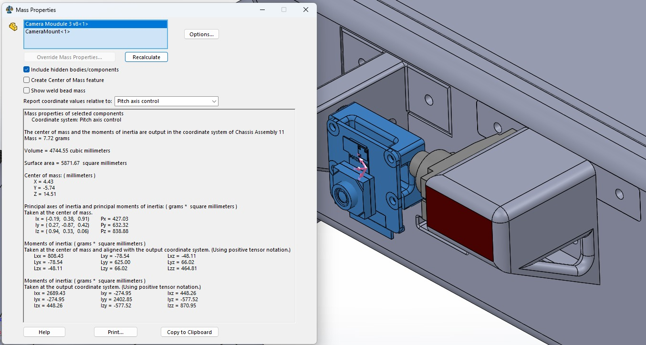

$τ=n[[Iα](3)+m\left(r×g\right)⋅a]$ (1)
Where n, I and \alpha are the safety factor on the torque requirement, matrix moment of inertia of the camera and camera mount about the servo rotation axis (pitch axis) and the angular acceleration of the camera and camera mount; $r$, $g$ and $a$ are the position vector to the centre of mass of the subsystem assembly from the servo attachment point, gravity vector and the axis of rotation, respectively.
Setting
$α = \left[\begin{matrix}0 \\ \frac{π}{2} \\ 0\end{matrix}\right]$ (3)
$g = \left[\begin{matrix}0 \\ -9.81 \\ 0\end{matrix}\right]$ (4)
$a = \left[\begin{matrix}0 \\ 0 \\ 1\end{matrix}\right]$ (5)

$n = 2$ (6)
yields:
τ = 7e-4 Nm (7) $τ = 7e-4 Nm$ (7)
The MG92B ${360}^{0}$ servo has a stall torque at 5V of 0.304Nm (The PiHut, 2026), therefore this servo is suitable for the pitch control of the camera and its mount.

Appendix E: Engineering Drawings
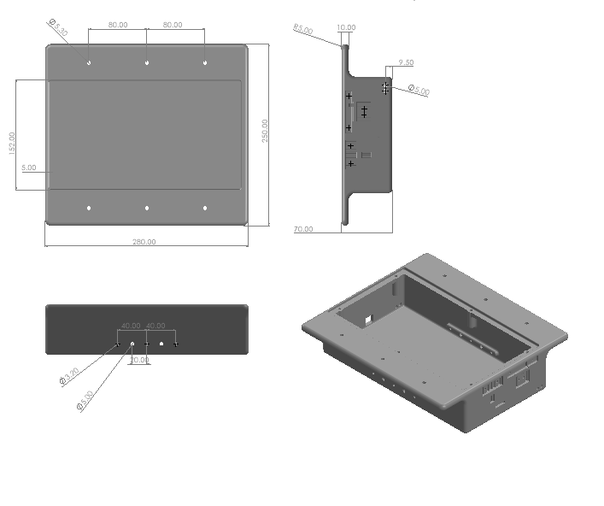
Figure E1: Chassis Engineering Drawing
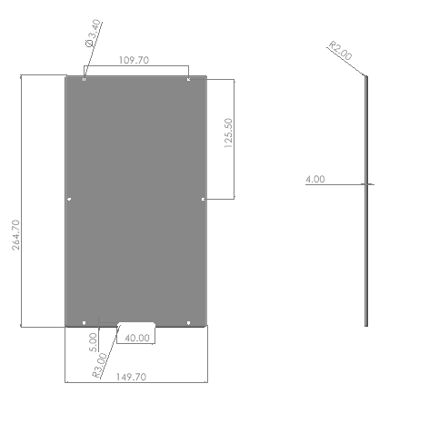
Figure E2: Chassis Lid Engineering Drawing
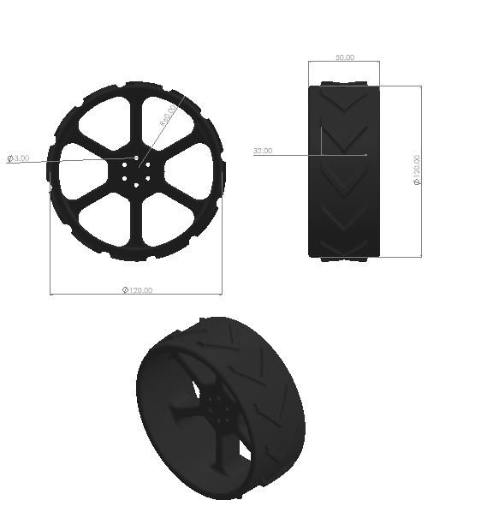
Figure E3: Wheels Engineering Drawing

Appendix F – Vibration analysis

F.1.0 – Modal Analysis
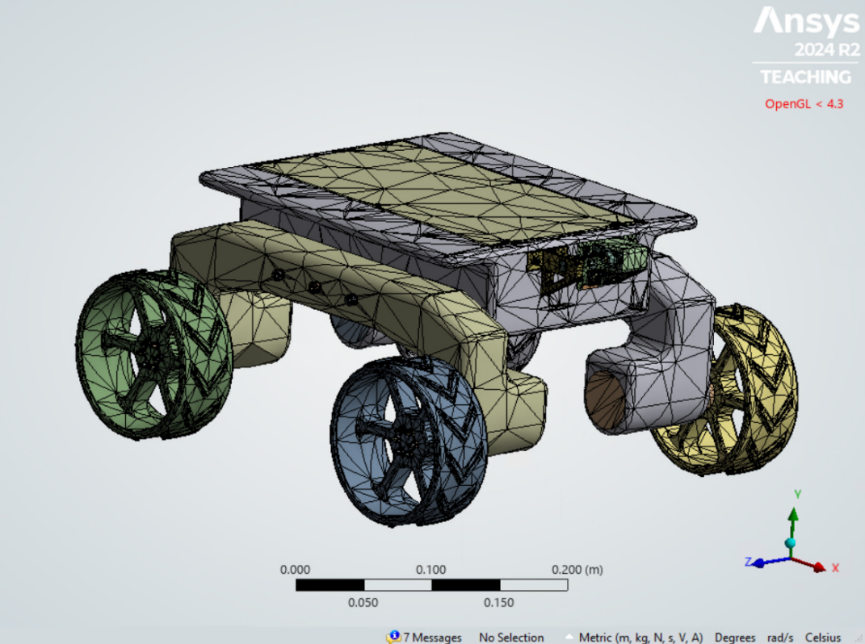

Figure F1: Rover mesh, elements :235551, nodes: 441711

Due to the high number of small bodes embedded within the electrical component CAD, to save computational resources and time, the mass of all of the electrical components were distributed across two batteries within the chassis and the material of the battery set to PE with a custom set density of 3261 kg m⁻³ to account for the mass of the components. The motors, motor hub – motor shaft interface mounts and motor – motor mount interface were approximated using cylinders with assigned material being stainless steel. The purpose of which was to simulate the function of screws and bolts within the assembly which had no publicly available cad files.
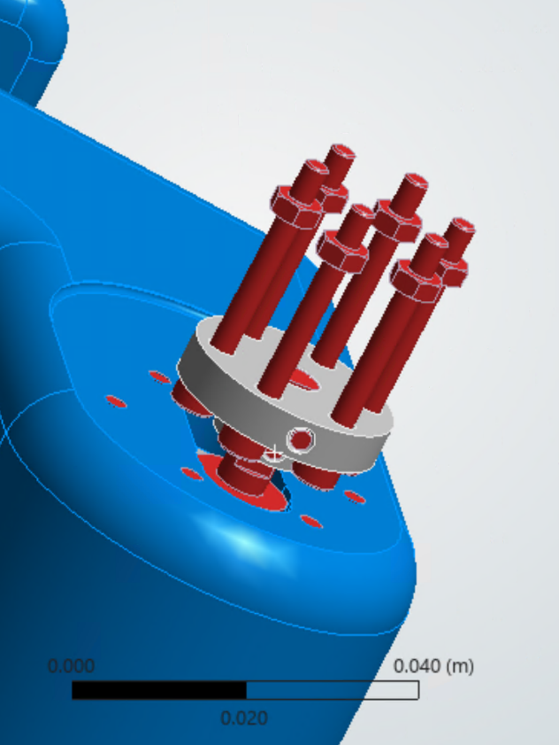

Figure F2: Stainless steel material assignment

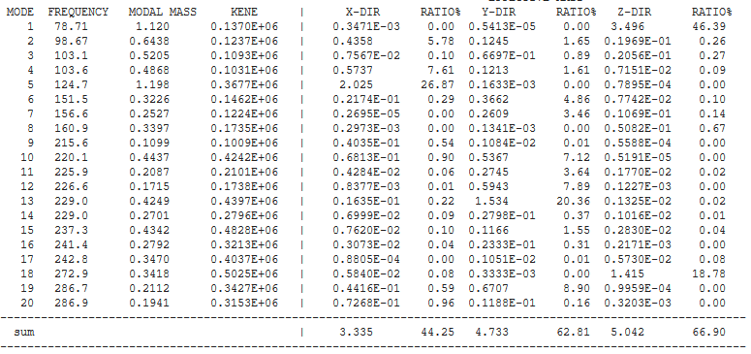

Figure F3: Modal analysis results with 20 modes evaluated

Based on the modal analysis, the x-direction (refer to Figure X) will be specified as the vibration axis as the this has the lowest overall modal mass participation ratio (MMPR). The highest x-axis MMPR occurs at mode 5.
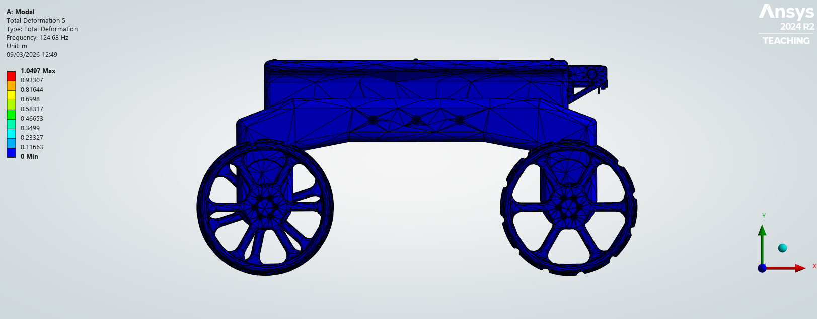

Figure F4: Zero displacement of rover in fifth mode oscillation cycle

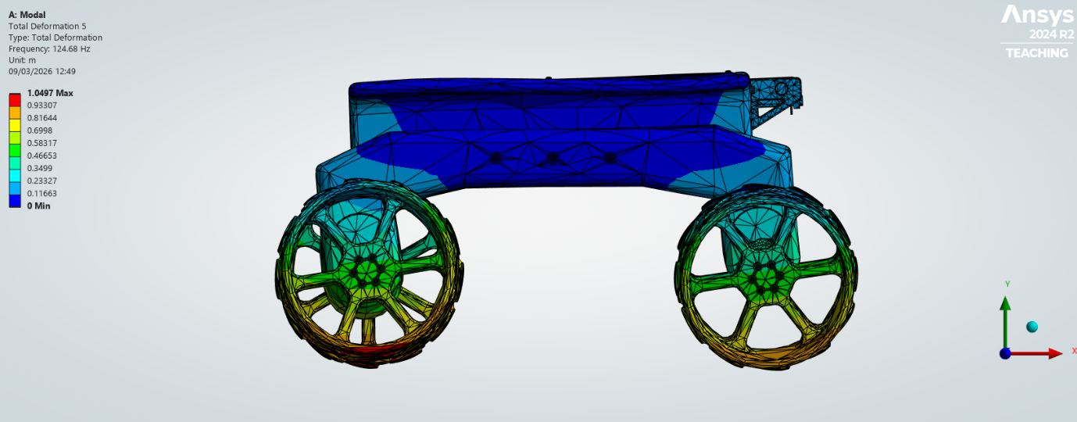

Figure F5: Max displacement of rover in fifth mode oscillation cycle

F.1.1– Harmonic Response
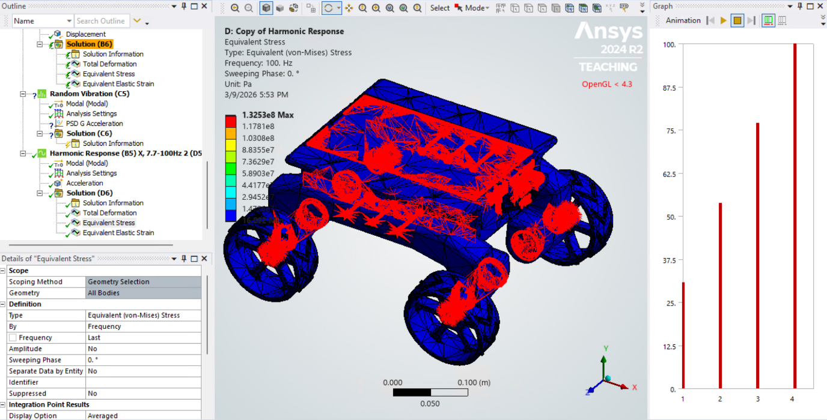

Figure F6: 7.7-100Hz harmonic response 3g amplitude x-direction stress analysis
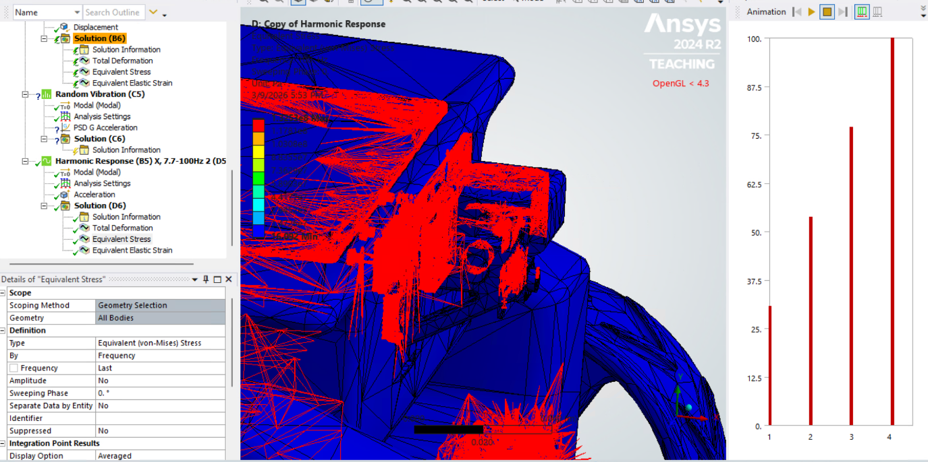

Figure F7: A section including the camera mount stress analysis of the 7.7-100Hz harmonic response 3g acceleration vibration simulation.
Note that the graphic quality of the stress contours is poor due to the relatively low number of elements run due to insufficient compute power and that the stress in Figure E7 is concentrated in the structural components which will be bolted and superglued to the chassis.

